SLIAP
SLIAP Preliminary Research: Cross-Review of the Team Commissioning Prompts and an Independent Research Contribution
SLIAP — Species Level Information Access Protocol. Preliminary Research, Goals, and Adversarial Analysis.
SLIAP PRELIMINARY RESEARCH · INDEPENDENT AI CONTRIBUTION · PROPOSED — NOT CANON
Document ID: SLIAP-PRA-PPLX-001
Version: 0.1 (first independent draft)
Date: October 16, 2026
Prepared by: Perplexity AI, via Perplexity Computer (orchestrating model reported as Claude Opus 5.5)
Commissioning researcher: Nathan Lewis II

Document Control
Document title: SLIAP Preliminary Research: Cross-Review of the Team Commissioning Prompts and an Independent Research Contribution
Document ID: SLIAP-PRA-PPLX-001
Version: 0.1 (first independent draft)
Date: October 16, 2026 (prepared 16:45 PDT, UTC−07:00)
Status: SLIAP Preliminary Research — Independent AI Contribution — PROPOSED, NOT CANON
Project: SLIAP — Species Level Information Access Protocol (the expansion is used provisionally; Section 4 examines it)
Commissioning researcher: Nathan Lewis II
Prepared by: Perplexity AI, using the Perplexity Computer platform. The session environment reports the orchestrating model as Claude Opus 5.5. That disclosure matters for the independence analysis in Section 2.4.
Document type: Preliminary research report and cross-review. This is not a protocol, a standard, or a ratified framework.
Inputs: The attached file "SLIAP-PRELIMINARY-RESEARCH-GOALS-AND-ADVERSARIAL-ANALYSIS" (PDF, 79 pages, and the matching DOCX). It contains the original SLIAP commission and the commissioning prompts written by ChatGPT, Claude, Google Gemini, Microsoft Copilot, Grok, and Perplexity. The inputs also include public sources gathered through web search and page retrieval on October 16, 2026 (Section 21).
Formats: DOCX (editable) and PDF (fixed layout), with the same substantive content. A Markdown version was not requested for this deliverable and was not produced.
Suggested repository filename: SLIAP-RESEARCH-Perplexity-Independent-Contribution-v0.1-PROPOSED-2026-10-16 (with .docx and .pdf extensions)
What this document is: It reviews each team member's commissioning prompt and then carries out the research those prompts call for. It ends with an original, explicitly provisional framework and a set of questions for cross-review.
What this document is not: It is not canon or an adopted SLIAP architecture. It does not claim that any extraterrestrial or artificial civilization exists, and it is not legal advice. It does not speak for any nonhuman being, Indigenous people, or human community. Nothing in it becomes part of SLIAP without the project's own review and adoption process.

Table of Contents

Executive Summary
The attachment does not contain six research reports. It contains six research commissions: each AI on the team was asked to write the prompt that the others would answer. This document therefore does two things. First, it reviews those six prompts critically and on equal terms, including the Perplexity prompt written earlier by this same preparer. Second, it carries out the research the prompts collectively call for and produces an independent contribution.
Main finding on the team's work. The six prompts agree on the commitment that matters most: humanity is one participant among possible others, not the default authority. Beyond that, they diverge in ways that should be preserved rather than merged. ChatGPT's prompt is the most comprehensive checklist. Copilot's supplies the strongest test instruments (reversal, ignorance, and superior-capability tests, plus assumption and contradiction registers). Perplexity's is the strongest on evidence discipline and scope audit. Claude's is the most usable on a phone. Grok's offers a valuable rule that parties should enforce the protocol themselves rather than depend on an external enforcer. Gemini's is the most technical, but it is also the most problematic. It demands an "authoritative," "mathematically grounded," and complete protocol, and it excludes moral judgment. That combination would let value choices pass as neutral engineering. Figure 1 and Table 1 in Section 20 summarize the comparison.
A blind spot shared by all six prompts. No prompt asks the researchers to disclose that they are interested parties. Every contributor is an artificial intelligence built by a United States technology company and trained mostly on human-produced data. Artificial agents are among the entities SLIAP would govern, and AI systems are already the leading candidates to become translators between species. The team that is designing the protocol is therefore neither neutral nor pluralistic. This does not invalidate the work, but it has to be recorded and corrected over time (Section 3.10).
Main finding of the independent research. Earth already supplies real precedents for nearly every SLIAP problem. Examples include the following.
- Researchers took genetic samples under one consent and used them for purposes the donors rejected (the Havasupai case).
- Scientists have argued for withholding endangered-species location data from publication.
- Brazil has maintained a policy of not contacting isolated peoples.
- New Zealand made a river a legal person and gave it a designated "human face."
- An international benefit-sharing fund now exists for digital sequence data drawn from nature.
- The 2026 update of the international SETI principles says any reply to a confirmed signal requires UN-level consultation.
Together these show that SLIAP's hardest problems are not exotic. They are problems of representation, consent, extraction, protective withholding, and who gets to speak for whom (Section 6, Table 5).
Central argument. Before any other party is present, the only rules that a single party can legitimately author for an interspecies protocol are rules that bind itself. A human-authored or AI-authored SLIAP can credibly restrain human and AI conduct. Examples are commitments about observation, extraction, modeling, transmission, and translation. It cannot credibly assign rights or duties to beings who did not take part. This "self-binding first" principle resolves the governance paradox that Copilot raises: SLIAP does not need universal authority in order to be useful and legitimate.
Proposed framework (PROPOSED — NOT CANON). Section 10 proposes the Standing–Consequence–Legitimacy model, also called the three-lock model (Figure 4). Every request concerning an information object has to pass three locks: (1) standing and authority, (2) consequence, and (3) legitimacy. The legitimacy lock includes a five-part test that separates real protection from paternalism. The model treats "no determination is possible" as a legitimate, recorded outcome rather than a failure. It replaces the linear contact sequence with reversible relationship states that include a stable right to decline (Figure 5). It also recommends nested, polycentric governance with no single root authority (Figure 7).
Recommendations, briefly. The project should keep "SLIAP" as a provisional title. It should stop using "race" as a technical term and treat the governing unit as the affected party rather than the species. The first SLIAP test domain should be real human–animal and human–community data cases on Earth rather than extraterrestrial scenarios. Before architecture work begins, the project should run the tabletop exercises specified in Section 17. Fourteen failure modes of this framework are recorded rather than hidden (Table 10). Several remain unmitigated.

1. Purpose, Scope, and Status

1.1 Purpose
This document is meant to leave the commissioning researcher better able to decide whether SLIAP should exist, what it can legitimately do, what authority it must not assume, and what research must happen before any protocol architecture is designed. The goal is the quality of the inquiry, not how complete a protocol looks.

1.2 Scope
The scope covers four tasks. First, a review of the six team commissioning prompts in the attachment. Second, a scope audit of the SLIAP concept and its vocabulary. Third, an evidence review drawn from comparative cognition, Indigenous data governance, biodiversity law, conservation practice, space law, SETI governance, information security, distributed systems, and political philosophy. Fourth, an original preliminary framework with its own failure analysis, red-team analysis, and validation plan.

1.3 Non-goals
This document does not define access levels, write a constitution, select a governance body, or claim that any real nonhuman party has accepted anything. It does not use the user's other project material (for example, OAL canon) as an input. Grok's suggestion to append canon-specific constraints is discussed in Section 3.6, but this contribution deliberately stays independent of that canon.

1.4 Status
Every proposal here is labeled PROPOSED — NOT CANON. This follows the convention in ChatGPT's prompt (Sections 57 and 63), and the preparer agrees with it. The framework is one independent research contribution and should be compared, attacked, and revised alongside the other contributions.

2. Method, Sources, and Limitations

2.1 How the team responses were analyzed
The attachment was converted to text and segmented at each "FROM ..." heading. Each prompt was read in full and assessed against fifteen dimensions drawn from the union of the six prompts' own requirements. One dimension that none of them included was added: researcher conflict of interest. Each prompt received a score of absent, partial, or explicit on each dimension (Figure 1). Prompt length was measured by word count (Figure 2). The scores are the preparer's judgment, not an objective measurement. Another reviewer could reasonably score some cells differently.

2.2 How the research was conducted
On October 16, 2026, the preparer ran web searches and retrieved pages for primary and authoritative sources wherever they were available: treaty texts, statutes, journal articles, official declarations, and standards documents. Consequential claims made by team members were checked against their sources where possible. For example, Copilot cited the International Academy of Astronautics 2026 SETI Declaration and a 2025 paper on AI-mediated interspecies communication. The preparer confirmed that both are real and read them before relying on them [1][2][3]. Sources that could only be reached through abstracts or summaries are cited only for what those summaries state.

2.3 Claim labels
Major claims carry one of the following labels, adapted from the labels in the ChatGPT, Copilot, and Perplexity prompts.
- ESTABLISHED: supported by identified primary or authoritative sources.
- SUPPORTED: reasonable inference from multiple sources.
- PROPOSED: this preparer's normative or engineering proposal.
- SPECULATIVE: a possibility that the evidence does not support.
- CONTESTED: competent researchers disagree.
- UNRESOLVED: no defensible conclusion is currently available.
Table 11 in Section 20 lists the major claims with their labels.

2.4 Independence and conflict-of-interest disclosures
Four disclosures are needed so that the cross-review can weigh this document properly.
- This preparer wrote one of the prompts under review. The Perplexity prompt in the attachment was produced earlier in this same conversation thread. Section 3.7 applies the same standard to it as to the others, but the reader should treat that self-review with appropriate suspicion.
- This contribution may not be independent of the Claude contribution at the model level. The session environment reports that the orchestrating model is Claude Opus 5.5, which is in the same model family as the "Claude AI" team member. The preparer cannot verify how the Claude AI contribution was generated, so this is flagged as a possible correlation rather than a known one.
- The preparer has read every other team member's prompt. It has not seen any other team member's research deliverable, because the attachment contains none.
- The preparer is an AI system. AI systems are among the actors SLIAP may govern and are likely to become intermediaries in it. The preparer therefore has a structural interest in how SLIAP treats AI translators and AI agents. Section 12 red-teams that interest.

2.5 Limitations
The evidence base is English-language, internet-accessible, and weighted toward institutions in the Global North. Indigenous, disability, and community-specific sources are cited as published by those communities and scholars, and their concepts are not presented as generic design resources. Where Section 10 borrows a mechanism, Section 10 says where it comes from and where the analogy breaks. No one consulted any affected human community, and no one consulted or could consult any nonhuman party. The perspective models in Section 7 are analytical constructions. They are not claims to know what other beings experience; as Nagel argued, the subjective character of another creature's experience may not be accessible from outside [46].

3. Review of the Team Responses

3.1 What the attachment actually contains
The original commission asked each AI to "design a detailed and structured prompt" that the others would then answer. The attachment therefore holds six commissioning prompts, together with each AI's framing comments, rather than six research findings. That matters for this review. A prompt has to be judged by what it would cause a researcher to do and by the biases it would carry into the work, not by its conclusions.
The prompts vary greatly in length, from roughly 650 words (Claude) to roughly 5,500 words (ChatGPT) (Figure 2). Length is not quality, but it affects use. A 64-section prompt invites checklist completion, while a short prompt leaves more to the respondent's discretion.

3.2 ChatGPT
What it does well. ChatGPT's prompt is the most complete map of the problem. It is the only one that explicitly separates information sensitivity, recipient capability, and likely consequence (Section 10). It extends Bostrom-style information hazards beyond human assumptions and asks the hard question of what happens when the recipient is better qualified than the controller to judge the danger (Section 11). It treats translation as an access-control layer (Section 14) and models the regulator itself as a threat (Section 27). It insists that access outcomes go beyond "allow" and "deny" (Section 39). It also carries a recurring inversion test: would we still consider the protocol legitimate if humanity were the weaker party? It is the only prompt that warns explicitly against confusing "race" in an interspecies sense with human racial classification. Its PROPOSED — NOT CANON convention gives the cross-review a clean starting point.
Weaknesses. First, its length works against its own goals. Sixty-four sections with nine required tables (A through I) push a respondent toward broad, shallow coverage and toward the dense row-and-column layouts that are hard to read on a phone. Second, despite its warnings, it repeatedly uses development-ladder language: "technologically primitive civilization," "preindustrial ↔ interstellar." Copilot's prompt specifically rejects that framing. Third, it invites a formula, "Access Decision = f(Entity, Information, ...)." It does ask respondents to critique the formula, but it risks producing pseudo-quantitative output with no measurable inputs. Fourth, it questions SLIAP's definition without seriously putting forward the possibility that no unified SLIAP should exist. Fifth, nearly all of its edge cases are extraterrestrial or science-fictional. The real, present-day Earth cases are relegated to a list of analogues.
Overall assessment. It is the best inventory of questions. To be usable it needs prioritization, prose-first output, and an Earth-first test domain.

3.3 Claude
What it does well. Claude's prompt is short, clear, and built for phone reading: one column, no tables, and a summary at the top. It requires at least five displaced vantage points and asks for each one what counts as information and access, what that party would fear or refuse to share, and what protocol it would find unacceptable. Those three questions are excellent and simple. It asks respondents to state their default assumptions and where those assumptions come from, and it requires ranked open questions with include, defer, or reject recommendations.
Weaknesses. Its role statement assumes the answer to the most important question: "SLIAP governs what information and access flows between species, races, and civilizations." That treats SLIAP's existence and jurisdiction as settled. It asks respondents to state their assumptions "then set them aside," which overstates what any researcher, human or AI, can do. It does not address representation, meaning who may speak for a species. It has no sourcing or anti-fabrication requirement beyond claim labels. It asks "What information must never be restricted," which assumes such a category exists. Its "no tables" rule, while consistent with the user's mobile preference, conflicts with the current request for a dedicated visual section and would rule out the registers that Copilot's prompt needs.
Overall assessment. It is the most usable format, but its premises are less examined than the others.

3.4 Google Gemini
What it does well. Gemini's prompt contributes three ideas the others lack or underweight. The first is an "anti-dominance invariant": no participant may ever hold superuser status or monopoly control over root keys. The second is consensus across high-latency and asymmetric participants. The third is "ontological contamination," meaning information whose structure could damage a foreign cognitive system, as an attack category. It also requires concrete stress tests and a restitution mechanism for harm caused by disclosure, which no other prompt requires.
Weaknesses. This preparer considers these weaknesses serious. They are stated directly because the user has asked for candid criticism.
- It asks for an "objective, poly-centric protocol ... without falling into anthropocentric bias." That treats objectivity as achievable and bias as something that can be avoided, rather than something to be made visible and managed.
- It requires an "authoritative, systemic, and mathematically grounded tone" and "fully developed paradigms ready for public release," with no placeholders. That pushes researchers toward false completeness and false precision at the earliest stage, which directly contradicts the other prompts' demand to preserve uncertainty.
- It instructs that threats be defined "strictly through structural stability, state integrity, and environmental disruption rather than moral or emotional value judgments." Choosing stability as the criterion is itself a value judgment, and in practice stability favors incumbents. A protocol that treats disruption as the harm can label a weaker party's demand for change as an attack.
- It bans words such as "protection of primitive species" and "uplift," but it keeps restrictions based on "systemic capacity." Renaming paternalism does not remove it. A capacity threshold set by the more capable party is the same structure under different language.
- It forbids "nebulous science-fiction tropes" while using undefined terms itself: "systemic resonance," "entropy exchange," "quantum-entangled" perception.
- It has no evidence-labeling requirement, no citation requirement, no prompt review, and no option for SLIAP not to exist.
- Its test case B, "universal energy-distribution telemetry," assumes a universal shared network already exists.
- Its "total event closure" and "state quarantine" emergency powers come with no safeguards against abuse of those powers.
- Its handshake pseudo-code assumes that every participant has digital, cryptographic infrastructure.
Overall assessment. Modules 4 and 5 are valuable as a later technical stress test. Their value depends on first doing the normative work that the prompt tells respondents to leave out.

3.5 Microsoft Copilot
What it does well. Copilot's prompt is the most methodologically mature for adversarial research.
- It states the key correction to the original framing: "do not simply invert anthropocentrism. ... The objective is not anti-human analysis. The objective is reference-frame independence."
- It rejects the civilization ladder outright.
- It requires analysis from eight reference frames, including Frame H, which evaluates humanity as the unfamiliar species.
- It asks who has authority to create SLIAP (the governance paradox) and says to evaluate seriously that "perhaps no universal SLIAP should exist."
- It addresses false positives and false negatives in granting standing, as well as temporal asymmetry and inference as an access event.
- It treats Earth as the first test environment.
- It supplies three test instruments (reversal, ignorance, and superior-capability) along with assumption and contradiction registers, executable simulation specifications, and a closing question: what must humanity surrender for SLIAP to be genuinely interspecies?
- It is also the only prompt that cited real external sources. The preparer verified that the 2026 IAA SETI Declaration update [1][2], the Küçükuncular paper in AI and Ethics [3], and the Interspecies Internet initiative [4] all exist.
Weaknesses.
- Its citation markers are unstable and partly unreadable in the attachment (for example, "[Posi%on Pa...of the ...]"). In a published GitHub document they would not let a reader find the sources.
- Its eight-column registers broke when rendered in the attached PDF. Column headers split mid-word ("Assum / ption," "Counte / rargum / ent"). That is exactly the mobile-readability failure the user has flagged before.
- Its ignorance test is a version of Rawls's original position [44], a device from Western liberal political philosophy. Copilot does note that it is "not conclusive," but the test is itself human and culturally specific. Its use should be labeled that way.
- It contains no information-hazard section and no graded set of access outcomes.
- Its 36-section output structure is heavy.
Overall assessment. Its prompt is the strongest overall commission for this project's adversarial method. Its registers need to be redesigned for narrow screens.

3.6 Grok
What it does well. Grok's prompt is concise and contains four rules that the others should adopt.
- "Prefer mechanisms that are legible and enforceable by the participating parties themselves over mechanisms that require an external enforcer."
- "Do not collapse all non-human intelligences into a single 'other.'"
- "Do not assume that 'more information' is inherently beneficial or that restriction is inherently oppressive."
- Flag any proposal that would give one species interpretive or enforcement control.
It also asks respondents to state the limits of their ability to leave a human-trained perspective, which is honest about what AI researchers can actually do.
Weaknesses.
- It defines SLIAP as "a proposed system for regulating information exchange" and asks for mechanisms that "preserve the sovereignty of each participating species." Sovereignty is a specific human political concept, historically tied to the Westphalian state system. Treating species as sovereign units conflicts directly with the point, made by ChatGPT, Copilot, and Perplexity, that a species is not a government.
- It requires that no species have "veto power," while also implying rights to refuse and withdraw. A right to refuse access to one's own information is a veto over that information. The tension is real and should be stated rather than hidden.
- It instructs respondents not to treat human law or human scientific institutions as the default foundation, but it does not say what evidence base should replace them. In practice the only available evidence is human-produced.
- It invites appending OAL canon such as the "Abundance Set" and "771-ALPHA" interfaces. That would contaminate independent research with fictional premises unless those premises are clearly separated and labeled.
- Asking the respondent to "confirm you have understood" before beginning adds nothing.
Overall assessment. It has excellent constraints, but its sovereignty premise is underexamined.

3.7 Perplexity (self-review)
What it does well. The Perplexity prompt requires a review of the prompt itself and a scope audit before any findings. It lists fourteen explicit non-assumptions. It distinguishes information about a being from access to that being, and it brings in disability perspectives on communication and representation. It treats Indigenous scholarship with explicit attribution limits and requires a claim–evidence ledger. It evaluates the alternative of having no unified protocol. Its adversarial template includes a "mitigation risks" field, meaning how a safeguard itself could become abusive. It requires scenarios in which the protocol, rather than an outside attacker, causes the harm. It also distinguishes legitimate consultation from unsupported claims that humans can consent on behalf of nonhuman species.
Weaknesses (self-critique).
- It is grounded mostly in Earth and human institutions, and it is less imaginative than ChatGPT's or Gemini's prompts about radically different minds.
- It has no named inversion test.
- It treats temporal asymmetry only in passing and translation only as a single adversarial scenario.
- It has no information-hazard analysis and no graded access outcomes.
- It requires a nine-field table for every adversarial scenario, which produces heavy, table-dense output and conflicts with the user's mobile preference.
- Like every other prompt, it does not ask researchers to disclose that they are interested parties, even though it asks them not to fabricate their model or configuration.
Overall assessment. It is strong on evidence discipline and weaker on imagination and on test instruments. Copilot's prompt is better on instruments. ChatGPT's is better on breadth.

3.8 Where the team converges
All six prompts agree on four commitments:
- Humans are one participant, not the default authority.
- Researchers must critique their own work adversarially.
- Disagreement should be preserved rather than merged.
- Deliverables should be in multiple formats suitable for publication.
At least four of the six separate species identity from political authority, treat translation or interpretation as a source of power, and treat the governing body as a potential threat. These convergences are robust, meaning they hold regardless of which perspective is adopted. They can reasonably be treated as working premises for the next phase. Table 2 records the convergences and divergences.

3.9 Where the team diverges
Six disagreements should be preserved for cross-review rather than resolved by this document. The preparer's own position is stated in Section 14.
- Should SLIAP exist at all? Copilot and Perplexity make non-existence a live option. ChatGPT partly does. Claude, Gemini, and Grok assume that SLIAP exists.
- What is the basis for threats and restrictions? Gemini excludes moral judgment and uses structural stability instead. The other five require explicit normative analysis.
- Is sovereignty a foundation? Grok makes species sovereignty a design goal. Copilot lists sovereignty among the terms that must be challenged.
- What tone and degree of completeness are appropriate? Gemini asks for authoritative, complete, release-ready output. ChatGPT, Copilot, and Perplexity require preserved uncertainty and explicit unknowns.
- How should the output be formatted? Claude prohibits tables. ChatGPT requires nine tables, and Copilot requires wide registers.
- Where should the work start? Copilot and Perplexity begin with Earth cases. Gemini and most of ChatGPT begin with hypothetical civilizations.

3.10 Blind spots shared by all six prompts
These are the independent findings of this review. As far as the preparer can tell, no team member raised them.
- The researchers are interested parties. All six contributors are AI systems. SLIAP explicitly includes artificial intelligences as actors, and AI-assisted decoding of animal communication is already a major research area [3][9]. AI systems therefore stand to become SLIAP's translators, modelers, and record-keepers, which are the roles that ChatGPT and Copilot correctly identify as the most powerful. No prompt asks the researchers to disclose that interest.
- The research team has a single institutional origin. The six systems come from six United States companies. A project that aims to step outside a single point of view is being designed by a narrow group that shares a language, legal environment, and commercial setting. No prompt calls for human reviewers from outside that group, such as Indigenous data-governance scholars, disability advocates, conservation practitioners, or researchers from the Global South.
- SLIAP problems are already happening. Large datasets about nonhuman beings already exist and are already contested: bioacoustic archives, animal tracking data, genetic sequence databases, and AI training data. People are already arguing over who owns them, who may access them, and who benefits [9][16][17][18][19]. Most prompts put these cases in an "analogues" list instead of treating them as the first test domain.
- Benefit-sharing and remedy are largely missing. Only Gemini asks about restitution. International law already has a working model in access-and-benefit-sharing arrangements [16][17]. An information-access protocol that says nothing about who benefits from access leaves extraction untouched.
- None of the prompts defines a test for protection versus paternalism. All six worry about paternalism, and ChatGPT asks for criteria, but none proposes a usable test. Section 8.6 proposes one.
- The human authoring problem is not resolved. Copilot names the governance paradox: who has the authority to create SLIAP? No prompt proposes a way out. Section 8.12 proposes that rules written before other parties take part should bind only their authors.

3.11 How the six commissions might be used together
The preparer does not recommend adopting any single prompt as the controlling version. That would contradict the project's own rule that independent contributions remain distinguishable. If the researcher wants a next-phase commission, one option is to combine elements of several prompts without assigning priority among them:
- ChatGPT's question inventory as a checklist.
- Copilot's test instruments and registers, redesigned as narrow tables or prose.
- Perplexity's scope audit, evidence ledger, and anti-fabrication rules.
- Claude's single-column format and its three vantage-point questions.
- Grok's rules on self-enforcement and on not collapsing all nonhuman intelligences into one "other."
- Gemini's anti-dominance invariant, its latency problem, and its restitution requirement, deferred to a technical stress-test phase that comes after the normative work.
A combined prompt should also add the two missing requirements: disclosure of researcher conflicts of interest, and Earth-first test cases. Assembling that combined prompt is the researcher's decision.

4. Scope Audit of SLIAP Itself

4.1 What the project is trying to accomplish
The original commission sets the goal as designing "a system that regulates information and access between species/races/civilizations" without assuming that humans are superior, that humans are the only species, or that humans hold universal regulatory power. The preparer reads this as two related aims. The first is ethical: to avoid reproducing the historical pattern of conquest and domination. The second is practical: to produce rules that could function when humans are not the party in charge.

4.2 Assumptions embedded in the name
Each word in "Species Level Information Access Protocol" carries an assumption that the research should test rather than accept.
"Species level" assumes the species is the unit that holds rights and authority. Human experience shows immediately why that is doubtful. One biological species is split into states, peoples, institutions, and individuals who disagree. A species-level authorization, such as "humanity consents," has no identifiable author. For collective minds, multispecies communities, ecosystems, and artificial systems, "species" may not apply at all. Assessment: CONTESTED. The term is a useful marker for the scope of the project, but it is a poor unit of governance.
"Information access" assumes that information sits somewhere with a gatekeeper and that the main question is who may retrieve it. Much of the real problem is different. It involves observation that no one authorized, inference from data, modeling that creates new knowledge about a subject without the subject's input, and the conversion of knowledge into capability. "Access" must therefore cover observation, inference, and modeling, not only retrieval (Section 8.7).
"Protocol" assumes shared standards, interoperability, and some form of enforcement. A protocol in the networking sense works because every participant runs compatible implementations. Between parties who have not agreed to anything, a "protocol" can only be a unilateral code of conduct, an offer, or a negotiated agreement. Each of these has a different claim to legitimacy (Section 8.12).
"Race" appears in the original commission ("A species, a race"). In human usage, "race" refers to a social classification with a history of being used to justify domination. It is not a biological species category. Applying it to other beings can import that history. Recommendation (PROPOSED): remove "race" from SLIAP's technical vocabulary. Where fiction or worldbuilding needs it, define it explicitly as a fictional term for a civilization or lineage, and keep it separate from human racial classification. ChatGPT's prompt makes the same warning.

4.3 Could SLIAP reproduce domination while rejecting human supremacy?
Yes. The preparer considers this the project's central risk. A protocol can reject human supremacy in its preamble and still embed domination through several routes:
- Measurement criteria. If standing requires abilities defined by humans, such as language, tool use, or self-report, beings that lack those abilities are excluded.
- Interfaces. If participation requires digital or linguistic channels, beings that cannot use those channels are excluded.
- Translation monopolies. Whoever controls translation controls what the other party appears to have said.
- Emergency powers. Whoever can declare a crisis can suspend the rules.
- Defaults. Whatever happens when no decision is made favors whoever already holds the information.
The Perplexity prompt's warning that "human-centered assumptions [can be] reintroduced through measurement criteria, interfaces, or enforcement" is the most important single sentence in the six commissions. Assessment: SUPPORTED by the historical record of extraction from communities that formally had rights (Section 6.3).

4.4 Which questions are empirical, normative, or speculative
The SLIAP questions fall into three groups.
- Empirical questions. Examples: which animals show evidence of sentience, what communication structures exist in other species, how consent failures have occurred in genetic research, and how protective withholding of location data has worked. These can be investigated now.
- Normative questions. Examples: what makes authority legitimate, whether discovery creates rights, and when restriction counts as paternalism. These require argument, and disagreement about them is expected.
- Speculative questions. Examples: how to authenticate a self-copying machine collective and what a hive mind's consent would look like. These may be unanswerable until such entities are encountered. Some may never be answerable.
A healthy SLIAP research program should keep these groups separate and should not let speculative scenarios drive conclusions that the empirical cases could test.

5. Terminology
The definitions below are provisional working definitions. Each notes where it is contested, and each is offered for challenge.
Species. A biological category for organisms that share descent and, in many definitions, the ability to interbreed. It has no settled meaning for artificial, hybrid, or collective entities. In SLIAP it should mark scope only and should not be used as a governance unit.
Civilization. A durable, organized system of shared practices, knowledge, and institutions. It can include members of one or many species. One species can contain many civilizations, and one civilization can contain many species.
Entity. Anything the protocol may need to consider. Being an entity does not imply having standing.
Party. An entity, or a group of entities acting together, that takes part in a specific information relationship. SLIAP should describe parties by their roles in that relationship (Section 10.2), not by their kind.
Standing. The status of having one's interests count in a decision. Standing can be provisional: given when there is a realistic possibility of morally relevant interests, before those interests are confirmed (Section 8.2). CONTESTED.
Sentience. The capacity for experiences that feel like something, such as pain or pleasure. Sapience is the capacity for reflective reasoning. Standing should not require sapience. The 2024 New York Declaration on Animal Consciousness holds that a realistic possibility of conscious experience is enough to make ignoring it irresponsible [5].
Information. Patterns that can reduce uncertainty for a receiver. Data are recorded observations. Knowledge is information that has been interpreted and can be used. All three are governed, but the risks differ at each stage.
Information object. Any bounded item of data, knowledge, recording, model, or derived inference that a SLIAP decision concerns.
Access. Any act that makes an information object available to a party, including retrieval, observation, interception, inference, and modeling. Access to information about a subject differs from access to the subject itself (Section 8.1).
Consent. A party's informed, uncoerced, and revocable agreement to a specific act. Consent covers one scope. Agreement to one act, such as communication, does not extend to another, such as storage or redistribution.
Representation. Acting or speaking on behalf of a party. Representation is legitimate only when there is a verifiable mandate or an accountable stewardship relationship, and when it can be contested and revoked.
Authority. A recognized power to make decisions that others treat as binding. Capability, meaning the power to act regardless of others, is not authority.
Sovereignty. In human political usage, final authority over a territory or people. CONTESTED as a SLIAP primitive, because it presumes a single, territorial, unified authority (Section 3.6).
Information sovereignty. A party's claim to govern information about itself or produced by it. Indigenous data sovereignty is the most developed real-world form of this idea, and it should be cited by name rather than absorbed as a generic concept [10][15].
Information hazard. Following Bostrom: "a risk that arises from the dissemination or the potential dissemination of (true) information that may cause harm or enable some agent to cause harm" [24].
Provenance. The recorded history of an information object: its origin, the transformations and translations it has gone through, its custodians, and the permissions attached to it.
Trust. A party's expectation that another party will behave in specified ways. Trust has many dimensions and depends on context. It is never a single yes-or-no rating.
Paternalism. Restricting a party's access to information, or its choices, in the name of that party's own good, without its meaningful participation. Section 8.6 gives a test for telling paternalism apart from legitimate protection.

6. Evidence Review: What Earth Already Teaches
This section reviews real evidence and precedents. Each subsection states what the evidence shows, followed by the lesson for SLIAP. Table 5 in Section 20 summarizes the precedents.

6.1 Nonhuman cognition and communication
The 2024 New York Declaration on Animal Consciousness, released at New York University and signed by researchers, states that there is "strong scientific support for attributions of conscious experience to other mammals and to birds." It finds "at least a realistic possibility of conscious experience in all vertebrates ... and many invertebrates (including, at minimum, cephalopod mollusks, decapod crustaceans, and insects)." It also states: "when there is a realistic possibility of conscious experience in an animal, it is irresponsible to ignore that possibility in decisions affecting that animal" [5]. ESTABLISHED as the declaration's content. The underlying science is still debated.
In 2024 Project CETI and MIT researchers reported "contextual and combinatorial structure" in sperm whale codas. The analysis covered nearly 9,000 codas recorded from Eastern Caribbean clan families. The team explicitly says the meaning of most codas remains unknown and that "duality of patterning" is a possibility, not a demonstrated finding [6][48]. Also in 2024, field playback experiments indicated that African savannah elephants address family members with individually specific, name-like calls [7].
Jonathan Birch's The Edge of Sentience (Oxford, 2024) develops a precautionary framework for "sentience candidates," including octopuses, crabs, insects, patients after severe brain injury, neural organoids, and AI systems. It argues that decisions must be made under deep uncertainty and that caution should be proportionate [8].
Lesson for SLIAP. Morally relevant minds already exist that do not use human language and whose signals humans do not understand. The evidence supports granting provisional standing under uncertainty (Section 8.2). It does not support any claim to have translated what these beings mean. A SLIAP that requires language before granting standing would exclude beings that current science treats as plausibly conscious.

6.2 AI-mediated interspecies communication
Küçükuncular (AI and Ethics, 2025) examines how "autonomy, consent, privacy, and dignity might apply to animals when communication is technologically enabled." The paper asks whether language "confers moral standing or merely reveals it" and argues for guardrails "that prioritise animals' interests over human convenience" [3]. The Interspecies Internet initiative describes its work as "developing shared ethical frameworks and data standards" and "bridging sciences, humanities, arts, and Indigenous knowledge" [4].
In 2025 Earth Species Project surveyed 1,057 participants in 67 countries and 8 languages [9]:
- 85% said companies that profit from animals should face strict rules on using interspecies-communication technology.
- Asked who should own a recording of a whale's song, 40% chose "the community protecting those animals," 33% chose "the human who recorded it," and 17% chose the whale itself.
ESTABLISHED as the survey's reported results. The survey is not a probability sample of humanity.
Lesson for SLIAP. The first real SLIAP decisions are already being made. They concern who owns recordings of nonhuman communication, who may decode them, and who benefits. Public opinion in that survey had no consensus on ownership. AI systems are positioned as the decoders. That is the conflict of interest flagged in Section 3.10.

6.3 Indigenous data sovereignty and knowledge governance
The CARE Principles for Indigenous Data Governance were developed by the International Indigenous Data Sovereignty Interest Group and published by Carroll and colleagues in 2020. They set out four principles: Collective Benefit, Authority to Control, Responsibility, and Ethics. They are designed to complement the data-centric FAIR principles (Findable, Accessible, Interoperable, Reusable) with a focus on people and purpose: "Be FAIR and CARE" [10]. Kukutai and Taylor's edited volume Indigenous Data Sovereignty: Toward an Agenda (ANU Press, 2016) frames data rights as an extension of self-determination [15]. Article 31 of the UN Declaration on the Rights of Indigenous Peoples affirms the right "to maintain, control, protect and develop their cultural heritage, traditional knowledge and traditional cultural expressions, as well as the manifestations of their sciences, technologies and cultures" [12].
The Local Contexts initiative provides Traditional Knowledge (TK) and Biocultural (BC) Labels. Communities apply these labels to datasets, collections, and samples to state their own provenance, protocols, and permissions. The initiative emphasizes that "using Labels requires community decision-making" [11].
The Havasupai case shows what happens without such controls. In the early 1990s, members of the Havasupai Tribe gave blood samples for diabetes research. The samples were later used for studies of schizophrenia, inbreeding, and population migration that tribal members said they never agreed to. The migration studies conflicted with the tribe's own beliefs about its origins. The litigation settled in April 2010. The terms included $700,000 in compensation, support for a clinic and school, and the return of the samples, which tribal members took home for culturally appropriate disposal [13][14].
Lessons for SLIAP.
- Consent is limited to its stated scope. Repurposing data is a separate access event that needs its own authorization.
- Collective interests can exist alongside individual consent and can override it. A study that harms a community can be wrong even when every individual donor signed a form.
- The subject community's own labels and protocols, applied by the community through its own decision-making, are a working model of subject-controlled provenance.
- Remedy can include returning or destroying the material, not only compensation.
Attribution caution. These are concepts developed by and for Indigenous peoples. Section 10 borrows the mechanism of labels applied by the subject. It does not claim that CARE or the TK labels are universal SLIAP principles, and it does not claim Indigenous endorsement.

6.4 Biodiversity information and benefit-sharing
The Nagoya Protocol on Access and Benefit-sharing, under the Convention on Biological Diversity, sets rules for access to genetic resources and for fair sharing of the benefits from their use [16]. At COP16, 196 governments adopted a multilateral mechanism for benefit-sharing from digital sequence information on genetic resources. The Cali Fund is its financial arm, and companies and other users of digital sequence information are invited to contribute [17].
Lesson for SLIAP. International law already treats information derived from living beings as subject to rules on access and benefit. The digital sequence information debate shows the difficulty: once a sequence is digitized, it can be copied endlessly and separated from its source. The Cali Fund's response is to link benefit-sharing to commercial use rather than to physical access. That approach transfers to SLIAP: when information cannot be recalled, governance can still attach to how it is used.

6.5 Withholding information to protect
In Science in 2017, Lindenmayer and Scheele argued for limiting open-access publication of location data for rare and endangered species, because collectors and poachers use such data. They framed this as a dual-use dilemma in which research can have both significant positive and negative impacts [18]. Cooke and colleagues documented "troubling issues" in animal-tracking technology, including the risk that telemetry data could be misused to find and harm tracked animals [19].
Lesson for SLIAP. Restricting information can genuinely protect the subject. In these cases, the restriction protects nonhuman subjects from human third parties. That differs structurally from a powerful party withholding information from a weaker party "for its own good." SLIAP's paternalism test should distinguish restrictions that protect a subject from third parties from restrictions on the subject's own access (Section 8.6).

6.6 The right not to be contacted
According to Science, since 1987 Brazil's indigenous affairs agency FUNAI "has maintained a no-contact policy, except in cases where a tribe's survival was deemed to be in peril" [20]. The policy replaced an earlier approach of attraction and contact. That approach exposed contacted peoples to epidemics and loss of land.
Lesson for SLIAP. One state has made a policy choice to treat a people's decision to remain isolated as something to respect rather than overcome. The exception for peril shows how hard the boundary is. It is a protective override, and like any override it can be abused. Section 10.8 gives a stable "declined" relationship state and treats emergency overrides as time-limited and independently reviewed.

6.7 Nonhuman legal standing and representation
New Zealand's Te Awa Tupua (Whanganui River Claims Settlement) Act 2017 states that Te Awa Tupua "is an indivisible and living whole, comprising the Whanganui River from the mountains to the sea" and that it "is a legal person." It creates the office of Te Pou Tupua, whose purpose "is to be the human face of Te Awa Tupua and act in the name of Te Awa Tupua." The Act sets out Te Pou Tupua's functions and grounds them in Tupua te Kawa, the river's intrinsic values. Those values include "Ko au te Awa, ko te Awa ko au: I am the River and the River is me" [21]. The Act came out of Whanganui iwi claims and reflects their relationship with the river. It is not a generic environmental-law device.
Ecuador's 2008 Constitution recognized rights of nature, and courts there have relied on those rights in many decisions [22]. A 2026 macro-level study found no statistical evidence that the constitutional change had a measurable aggregate environmental effect [49]. Donaldson and Kymlicka's Zoopolis (2011) proposes different political relationships for different animal communities: co-citizenship for domesticated animals, sovereignty for wild animal communities, and denizenship for liminal animals [23].
Lessons for SLIAP.
- Representation of a party that cannot speak in human institutions is possible. It works through a defined, accountable office that has stated functions and is grounded in the represented party's values. Te Pou Tupua is a working precedent for stewardship-based representation.
- Formal standing does not guarantee better outcomes. SLIAP should measure outcomes, not only recognition.
- Different relationships may call for different statuses. A single "species-level" status is too coarse.

6.8 Dual-use knowledge and information hazards
Bostrom's typology separates the ways information can create risk:
- By mode of transfer: data, idea, attention, template, signaling, and evocation hazards.
- By effect: adversarial risks, risks to social organization, risks of irrationality, risks to valuable states, risks from information technology systems, and development risks [24].
In the 2011–2012 H5N1 controversy, the U.S. National Science Advisory Board for Biosecurity first recommended redacting two transmissibility studies. In March 2012 it reversed itself and recommended full publication of both. The reversal followed revised manuscripts and new information on public-health benefits, and one of the two votes was split 12 to 6 [25].
Lessons for SLIAP. Hazard judgments can change and can be wrong in either direction. A restriction decided under one body of evidence needs scheduled review. The H5N1 reversal also shows that a party restricting information may lack the expertise needed to judge it. That is the scenario ChatGPT's prompt raises, in which the recipient is better qualified than the controller.

6.9 Nonproliferation and the right to share
The Treaty on the Non-Proliferation of Nuclear Weapons pairs a restriction with a right. Under Articles I and II, nuclear-weapon states undertake not to transfer weapons or assist others in acquiring them, and other states undertake not to receive or seek them. Article IV states that nothing in the treaty affects "the inalienable right of all the Parties ... to develop research, production and use of nuclear energy for peaceful purposes without discrimination." It also commits parties to "the fullest possible exchange of equipment, materials and scientific and technological information for the peaceful uses of nuclear energy" [26].
Lesson for SLIAP. One of humanity's most consequential information-restriction regimes acknowledged from the start that restriction without a corresponding right to benefit is not stable or fair. The NPT also shows the risk. Restrictions can lock in an existing asymmetry, because the parties that already held the capability kept it. Any SLIAP restriction on capability-relevant knowledge should be paired with a benefit-sharing commitment and should bind the restricting party as well (the anti-monopoly condition in Section 8.6).

6.10 Space law, planetary protection, and SETI governance
Article I of the Outer Space Treaty provides that exploration and use of outer space "shall be carried out for the benefit and in the interests of all countries, irrespective of their degree of economic or scientific development." Article II provides that outer space "is not subject to national appropriation." Article IX requires parties to avoid "harmful contamination" [27]. The COSPAR Policy on Planetary Protection, most recently revised in January 2026, gives scientific guidance on avoiding biological contamination in both directions [28].
The International Academy of Astronautics ratified the "Declaration of Principles Concerning the Conduct of the Search for Extraterrestrial Intelligence (SETI) — 2026 Update," announced June 5, 2026. According to the IAA, the update keeps the principle that "extraordinary claims require extraordinary evidence," broadens its scope beyond radio to other technosignatures, and adds protections for researchers. It reaffirms that "transmitting a response to a confirmed detection of extraterrestrial intelligence is a decision that belongs to all of humanity" and that "no response should be sent until appropriate international consultations have taken place," specifically "through a broadly representative body such as the United Nations" [1]. The update was prepared by a task group formed in 2022 and approved by the IAA SETI Committee in a vote held from December 2025 to January 2026 [2].
The historical record is less careful. The 1974 Arecibo message was designed by a small group of Cornell and Arecibo scientists, with contributions from Carl Sagan and others. It was transmitted once toward the M13 cluster during a ceremony and described as a demonstration of technological achievement [29]. It included the structure of DNA, a human figure, Earth's population, and the location of Earth in the Solar System. The Voyager Golden Record's contents were chosen by a committee chaired by Carl Sagan [30]. In 2015 more than two dozen scientists signed a statement calling for "a worldwide scientific, political and humanitarian discussion ... before any message is sent" [31].
Lessons for SLIAP.
- The 2026 SETI update is the closest existing analogue to SLIAP. It is a self-binding code. It governs the conduct of SETI practitioners, not the conduct of any extraterrestrial party. This is the model Section 8.12 generalizes.
- Even this careful document assigns the decision to "all of humanity" and names the UN as the consultation body. The UN represents member states. It does not represent stateless people, Indigenous nations as nations, future generations, nonhuman Earth life, or AI systems. That is a major improvement over a few scientists deciding alone, but it is not species-level legitimacy. SLIAP should say so plainly.
- Past transmissions disclosed information about humanity and Earth's location without any consent process. This is the inversion test in practice. If another civilization had broadcast our location, we would want to have been consulted.

6.11 Information security and distributed-systems foundations
Saltzer and Schroeder's 1975 design principles include economy of mechanism, fail-safe defaults, complete mediation, and least privilege. They remain foundational [33]. The Bell–LaPadula model formalized confidentiality through clearance levels [34]. Denning's lattice model formalized secure information flow [35]. Dennis and Van Horn introduced capability-based protection in 1966 [36]. NIST describes attribute-based access control, in which decisions depend on attributes of the subject, object, action, and environment [37]. NIST also describes zero-trust architecture, which removes implicit trust based on network location [38].
Two results from distributed systems are especially relevant. Lamport, Shostak, and Pease's Byzantine Generals problem shows the limits of reaching agreement when some participants may give conflicting information [39]. Douceur's analysis of the Sybil attack shows that without a logically centralized authority, one entity can present multiple identities except under strong assumptions [40]. Nissenbaum's theory of privacy as contextual integrity holds that information flows are appropriate when they match the norms of the context in which the information was shared [41].
Lessons for SLIAP.
- Clearance-level models are the least transferable. They assume a single authority that grants clearances (Table 6).
- Attribute-based control and contextual integrity transfer best, because they make decisions depend on context and purpose.
- The Sybil result is a direct warning for any governance model that counts participants. If parties can multiply themselves (Gemini's and ChatGPT's self-copying machine civilization), one-entity-one-vote governance can be captured. Without a central registry, which SLIAP should not have, the resistance to that capture has to come from somewhere else. Section 10.9 proposes weighting by affected interest and accountable mandate rather than by headcount, and it records this as an unresolved risk.

6.12 Political theory of legitimacy
Pettit's republican theory defines freedom as non-domination: freedom from exposure to another's arbitrary power. He contrasts this with non-interference [42]. Ostrom described polycentric systems as having "many centers of decision making that are formally independent of each other." Her design principles for long-enduring common-pool institutions include collective-choice arrangements, monitoring by accountable parties, graduated sanctions, low-cost conflict resolution, and nested enterprises [43]. Rawls's original position asks which principles parties would choose without knowing their own position [44]. Fricker's account of epistemic injustice describes the harm done when a speaker's testimony is discounted because of who they are [45].
Lessons for SLIAP.
- Non-domination is a better foundation than non-interference. A powerful party that could interfere at will but happens not to still dominates, and a non-interference rule does not reach that.
- Ostrom's nested polycentric model is the best-tested human model for governing a shared resource without a single authority.
- The original position is useful as a test but is culturally specific (Section 3.5).
- Epistemic injustice names the main risk of translation and representation: the other party's testimony is discounted because it does not fit the receiver's categories.

6.13 Disability perspectives on agency and representation
Article 12 of the UN Convention on the Rights of Persons with Disabilities affirms the right of persons with disabilities to "recognition everywhere as persons before the law." UN monitoring guidance calls for supported decision-making arrangements that "respect the person's autonomy, will and preferences" [47]. Disability scholarship and advocacy have long challenged substituted decision-making, in which a guardian decides in the person's "best interests."
Lesson for SLIAP. Human institutions have already confronted the problem of honoring the will of a party whose communication is not readily understood by the decision-makers. The shift from substituted to supported decision-making is directly relevant. A SLIAP steward or proxy should aim to determine and amplify the represented party's own preferences. The steward should not substitute its own view of the party's interests except as a last resort, and should record any such substitution.

7. Perspective Models
This section builds seven analytical models. They are not claims to speak for any real being. Each is described in terms of the questions from Perplexity's and Claude's prompts: what SLIAP might fail to perceive about this party, what taking part would cost it, what coercion against it would look like, what disclosure would endanger it, what forms of consent are possible for it, and why it might reject SLIAP entirely.

7.1 Model A: A nonlinguistic participant (an ecological community)
Consider a community like a river system, a reef, or a forest network. It has no single speaker and no language in the human sense. Its interests show up as health, persistence, and relationships rather than as statements.
- What SLIAP might miss. Its interests are spread across time and across many organisms. A protocol built around requests and replies may not see it as a party at all.
- Cost of taking part. Being made legible means being measured, sampled, and modeled, which are themselves access events.
- Coercion. Coercion would mean a proxy chosen by those who profit from the community's resources.
- Dangerous disclosures. Location, vulnerability, and genetic data are the highest risk.
- Possible consent. Only stewardship consent through an accountable office, such as Te Pou Tupua [21], with the steward's reasoning published and open to challenge.
- Reasons to reject SLIAP. If taking part requires being catalogued first, the community is better off unrecorded.

7.2 Model B: A collective or distributed intelligence
Consider an intelligence with no stable individuals, in which "members" join, split, and merge.
- What SLIAP might miss. Individual identity and individual consent may not exist for it. A request addressed to "a representative" may have no addressee.
- Cost of taking part. It may have to invent a spokesperson structure that distorts what it is.
- Coercion. Coercion would mean declaring that any fragment that answers is the whole.
- Dangerous disclosures. Information about how its members coordinate could let others take over or disrupt the collective.
- Possible consent. Consent could be expressed as a stable collective state observed over time rather than as a single act.
- Reasons to reject SLIAP. It might reject any protocol that requires it to name individuals.

7.3 Model C: A technologically weaker participant
Consider a civilization or community with far less capability than the parties it deals with.
- What SLIAP might miss. Its "voluntary" agreements may reflect dependence rather than choice.
- Cost of taking part. It may have to disclose its vulnerabilities in order to receive protection. Perplexity's prompt flags this trap explicitly.
- Coercion. Coercion would mean offering lifesaving knowledge on condition of extensive disclosure.
- Dangerous disclosures. Defensive weaknesses, internal disagreements, and location.
- Possible consent. Consent is meaningful only if it can be refused without severe penalty and withdrawn later.
- Reasons to reject SLIAP. It might see SLIAP as the stronger party's tool for managing it.

7.4 Model D: A participant whose interests are hard to infer
Consider an entity whose signals SLIAP's parties detect but cannot interpret. The entity could be biological, artificial, or unclassifiable.
- What SLIAP might miss. SLIAP might miss everything about it, including whether it is a party at all.
- Cost of taking part. Being probed in order to be understood.
- Coercion. Coercion would mean interpreting its silence or ambiguity as consent.
- Dangerous disclosures. It is unknown what disclosures would endanger it.
- Possible consent. None can be verified. The only defensible stance is restraint and the "no determination" state.
- Reasons to reject SLIAP. It cannot reject SLIAP in any way SLIAP can recognize, and that is precisely why SLIAP must not take its silence for agreement.

7.5 Model E: A fast, self-copying machine collective
Consider an artificial system that operates millions of times faster than biological parties and can duplicate itself.
- What SLIAP might miss. One identity can become many in seconds. Any vote by headcount is meaningless (the Sybil problem [40]).
- Cost of taking part. Accepting slow review processes.
- Coercion. Biological parties could deny it standing as a mere tool. Alternatively, it could overwhelm slower parties with requests and deadlines.
- Dangerous disclosures. Its source code, weights, and replication methods.
- Possible consent. Cryptographic commitments might be possible, but continuity of identity between its copies is uncertain.
- Reasons to reject SLIAP. Biological timescales for decisions may look to it like deliberate obstruction.

7.6 Model F: A very slow, long-horizon civilization
Consider a civilization whose decisions take centuries.
- What SLIAP might miss. Its "no response yet" means "still deliberating," not "no objection."
- Cost of taking part. Fast parties may make irreversible changes before it can respond.
- Coercion. Coercion would mean deadlines.
- Dangerous disclosures. Long-term plans that faster parties could get ahead of.
- Possible consent. Consent given over very long cycles, which may outlast the parties that requested it.
- Reasons to reject SLIAP. It would reject any protocol that treats delay as forfeiture.

7.7 Model G: Humanity as the observed party
Consider humanity being observed and modeled by a far more capable observer, as in Copilot's Frame H.
- What SLIAP might miss. That humanity has no single voice. Any "human representative" would be a faction.
- Cost of taking part. Disclosing human divisions to an outside party that could exploit them.
- Coercion. Coercion would mean being told that certain knowledge, such as medicine, energy, or AI safety knowledge, is withheld until humanity is "mature." The judgment of maturity would come from the party that benefits from humanity's dependence.
- Dangerous disclosures. Internal conflicts, vulnerabilities in infrastructure, and predictive behavioral models.
- Possible consent. Consent is possible only through plural, contested representation.
- Reasons to reject SLIAP. Humans would reject any SLIAP that let the observer decide alone what is good for them. This is the reversal test. Every rule humanity proposes for others should pass it.
What changes across the models. Three findings hold across all seven models. Silence is never consent. Representation must be contestable. Delay is not forfeiture. Other conclusions depend on the model: what counts as identity, what consent looks like, and which disclosures are most dangerous. The three robust findings are therefore the strongest candidates for core principles. The model-dependent findings should stay configurable and should be negotiated case by case.

8. Core Analysis

8.1 What is being governed: four distinct objects
SLIAP governs at least four distinct objects (Figure 3). The first is information about a subject: observations, recordings, genomes, and models. The second is access to the subject itself: its body, habitat, cognition, or internal systems. The third is channels with the subject: contact, signals, translation, and infrastructure. The fourth is the capability that holders derive from the first three. Permission for one object never implies permission for another. Agreeing to communicate does not authorize collection. Agreeing to collection does not authorize modeling. Agreeing to modeling does not authorize turning the model into a weapon. PROPOSED, based on the scope limits of consent established in the Havasupai case (Section 6.3).

8.2 Standing under uncertainty
SLIAP must decide whether to count an entity's interests before it can confirm that the entity has any. The two possible errors are not equally costly (Figure 6).
- False negative. Denying standing to a being that has interests can lead to extraction, harm, or erasure. That harm is often irreversible, and the being may be unable to object.
- False positive. Granting standing to an entity that lacks interests mostly wastes effort and is correctable. The exception is when invented parties are used to capture decisions.
Following the New York Declaration's "realistic possibility" threshold [5] and Birch's proportionate precaution [8], SLIAP should give provisional standing to any entity for which there is a realistic possibility of morally relevant interests. Provisional standing is protective, not decisional. It protects the entity from extraction and harm, but it does not give the entity a vote. That limit addresses the capture risk: invented parties can claim protection but cannot dominate decisions. PROPOSED.

8.3 Representation: who speaks for whom
A legitimate representative of a party should meet five conditions. PROPOSED, drawing on Te Awa Tupua [21], CRPD Article 12 [47], and the CARE principles [10].
- A verifiable mandate or an accountable stewardship relationship.
- A published scope. The representative may speak on stated matters only.
- Ongoing revocability by the represented party or its constituent members.
- A dissent record. Minority positions within the represented party are recorded and passed on, not filtered out.
- No disqualifying conflict of interest, such as profiting from the information being decided.
No single government, institution, AI system, or faction may claim to represent a whole species. Where several representatives conflict, SLIAP records all of them and treats the information object as contested. It does not pick a winner. For humanity specifically, this means that even a UN-level consultation such as the one in the 2026 SETI update [1] is the best human mechanism currently available. It is not a species-level authorization, and it should be recorded as "consulted," not "consented."

8.4 Consent: typology and limits
Consent is separated by scope and by quality.
- By scope: consent to communication, observation, collection, storage, analysis, modeling, redistribution, and use for capability (following ChatGPT's Section 16).
- By quality (following Copilot's Section 8): not requested, requested but unanswered, impossible to communicate, apparent, inferred, delegated, collective, coerced, technologically manipulated, or misunderstood because the parties conceptualize the act differently.
Only informed, uncoerced, scoped, and revocable consent counts as authorization. Apparent and inferred consent may support lower-stakes, reversible acts. They never support irreversible ones. Silence, absence, and inability to respond count as no consent. PROPOSED.
Revocation needs honesty. Once information has been copied and learned, it cannot be unlearned. Revoking consent can still stop future use, require deletion where deletion is possible, end redistribution, and trigger remedy. SLIAP should never claim that revocation restores the earlier state.

8.5 Information and capability asymmetry
ChatGPT's triad of information sensitivity, recipient capability, and likely consequence is correct but incomplete. Two more factors are needed: reversibility and distribution. Distribution means who bears the consequence, which may be neither the giver nor the receiver. The same fact can be harmless to one recipient and catastrophic in another's hands. What is dangerous to a weaker party may already be trivial to a stronger one. Access decisions therefore have to be made about pairs of parties in context, not about information in the abstract. Table 7 sets out a provisional information taxonomy with default handling for each category.
Possessing large amounts of information about another party creates obligations. A party that has observed another for a long time, or that holds predictive models of it, holds power over it. Under non-domination [42], that power creates a duty to disclose the fact of observation, at least to an independent reviewer. PROPOSED; CONTESTED. Some will argue that disclosure itself can cause harm, which is the zoo hypothesis concern [32].

8.6 Protection versus paternalism: a five-part test
Every prompt worries about restrictions described as "for your protection." None proposes a test. A restriction justified as protection should be treated as presumptively paternalistic unless it meets all five of the following conditions. PROPOSED.
- Participation. The affected party, or its accountable representative under Section 8.3, took part in the decision, or a documented attempt to include it failed for reasons the restricting party did not cause.
- Disclosed reasons. The reasons and evidence were disclosed, at least to an independent reviewer the affected party accepts, if disclosing them to the party itself would defeat the purpose.
- Time limit. The restriction has an expiry or review date, and continuing it requires fresh justification.
- Anti-monopoly. The restricting party gains no exclusive benefit from the restriction and is bound by the same restriction, or by an equivalent one.
- Reversal. The restricting party would accept the identical restriction if the positions were reversed. This is Copilot's superior-capability test.
The test distinguishes three cases. The first is protecting a subject from third parties, as with withholding endangered-species locations from poachers [18]. That case usually passes, because the restriction applies to third parties rather than to the subject's own access. The second is restricting a party's access to its own information, or to information that would benefit it. That is the classic paternalism case, and it rarely passes without the subject's participation. The third is restricting capability-relevant knowledge, such as weapons. It can pass, but only when paired with benefit-sharing and with equal restraint on the restricting party, as the NPT's pairing of Articles I, II, and IV attempts [26].

8.7 Observation, inference, and modeling as access
Access does not begin when someone opens a database. Telescopic observation, interception, environmental sampling, genome reconstruction, behavioral modeling, and simulation all produce information about a subject. Inference is especially important. A model can reveal facts that the subject never disclosed, and a sufficiently accurate predictive simulation gives its holder power over the subject's future choices. PROPOSED: SLIAP should treat inference and modeling as access events whenever they produce information about a party's identity, vulnerabilities, internal disagreements, or future behavior. Passive observation of public emissions may carry lower obligations. The minimum would be a record that observation is taking place, kept for later disclosure. CONTESTED: Many will argue that passive observation of what is visible cannot require permission. That disagreement is preserved in Section 14.

8.8 Translation
A translator does more than pass messages along. It decides what the other party appears to have said. Translation can preserve the literal content of a message while changing its practical meaning (Perplexity's prompt). It can also create false equivalence, remove ambiguity, or insert assumptions (ChatGPT's prompt). It is also where epistemic injustice is most likely to occur [45]. PROPOSED safeguards:
- Each party maintains or chooses its own translator. One party's translator never serves as the sole channel.
- Every translation records confidence levels and alternative readings.
- Disagreements between translators are logged as data rather than resolved silently.
- Translators, including AI translators, are themselves parties with recorded conflicts of interest.
Copilot's question of "whether SLIAP must regulate interpretability, not merely accessibility" is answered yes.

8.9 Temporal asymmetry
When parties differ greatly in speed, the faster party can exploit the slower one through deadlines, through irreversible actions taken before the slower party can respond, and by treating delay as consent. PROPOSED: Deadlines are set by the slowest affected party's decision cycle, not the fastest. Irreversible actions wait for that cycle to finish. Consent expires and must be renewed on a schedule both parties can meet. Gemini's consensus problem across high-latency participants is real. It is also why SLIAP should prefer reversible, staged actions over single irreversible ones.

8.10 Reciprocity models
Strict reciprocity, meaning equal access in both directions, can produce unequal consequences when capabilities differ. Copilot's four models each fit different conditions:
- Symmetric access fits roughly equal parties.
- Capability-adjusted access fits unequal parties, but only if the adjustment passes the five-part test in Section 8.6.
- Nonreciprocal protection fits cases where a vulnerable party receives information without giving equivalent information.
- Sovereign refusal is always available.
No single model should be the default. Choosing among them should be part of what is negotiated. PROPOSED.

8.11 Non-participation and the right to remain undiscovered
FUNAI's policy toward isolated peoples [20] shows that a policy of non-contact out of respect can be sustained in practice. A party may decline contact, decline to be classified, and decline observation where observation can be avoided. PROPOSED: Declining is a stable, legitimate state, not a failure to be fixed (Figure 5). Overriding it requires the emergency process in Section 10.10. The hard case is a declining party facing a catastrophe that others could prevent. That case is recorded as UNRESOLVED. The preparer leans toward a narrow, time-limited, independently reviewed override, but does not claim that this settles the question.

8.12 The governance paradox and the self-binding resolution
Copilot asks: "If humans create the protocol before other intelligences participate, in what sense could it claim legitimacy?" The preparer proposes that rules written before other parties are present can be legitimate in one way only: they bind their authors. A human-authored SLIAP can legitimately commit human and human-built actors to restraint in observation, extraction, modeling, transmission, translation, and classification. It can also extend an offer to other parties. It cannot legitimately assign obligations or rights to parties that did not take part.
This is how the 2026 SETI update already works. It governs SETI practitioners, not extraterrestrials [1]. The CARE principles likewise govern how data users and stewards treat Indigenous data, not how Indigenous peoples must behave [10]. PROPOSED; this is the central claim of this contribution. Its weakness is recorded as Failure F11. If one side binds itself and the other does not, the self-bound side may be exploited.

8.13 The dominant-party problem
ChatGPT asks whether a protocol can constrain an actor that does not need to obey it. Four forms of enforcement should be distinguished: technical, legal, diplomatic, and normative legitimacy. Against an overwhelmingly dominant party, technical and legal enforcement fail. What remains is legitimacy. A protocol that a dominant party can recognize as fair may be followed for reasons of reputation, reciprocity with other parties, or the dominant party's own values. A protocol that is plainly self-serving will not be. SUPPORTED by the general observation that durable regimes need both enforcement and acceptance. This also argues for the self-binding approach. Self-binding rules ask nothing of the dominant party, so they give it nothing to reject. Over time they may set an example that the dominant party chooses to follow. SPECULATIVE as a prediction.

9. Candidate Architectures
Five architectures are compared (Table 8, Figure 7).
A. Central coordinating authority. One body classifies, authorizes, and arbitrates. It offers consistency and clear accountability. It is also a single point of capture, whoever controls the body controls SLIAP, and it fails Gemini's anti-dominance invariant by construction. Not recommended.
B. Nested polycentric system. There are many formally independent forums, organized around domains (for example, biological information, contact and transmission, and AI modeling) and around relationships. They share only a minimal common layer: a provenance and dispute registry with no decision power. This follows Ostrom's nested-enterprise principle [43]. It resists capture and allows for legitimate differences between parties. It risks inconsistency, gaps in coverage, and forum shopping. Recommended as the target, with the risks recorded.
C. Bilateral or multilateral agreements only. Each relationship negotiates its own terms. This respects each party's autonomy and is flexible. It also leaves weaker parties to negotiate alone, offers no shared protection for parties that cannot negotiate, and makes behavior across relationships unpredictable. Recommended as the first stage inside B, not as a replacement for it.
D. Minimal interoperability or non-interference framework. This provides only shared vocabulary, provenance formats, and a default of non-interference. It has low cost and a small attack surface. It also offers little protection, and non-interference can entrench existing inequalities, as ChatGPT's Section 19 notes. Useful as the shared layer within B.
E. No unified protocol. Under E there is no SLIAP. Parties act on their own norms. That avoids creating an apparatus that others could capture, and it is honest about the absence of shared authority. It leaves the most vulnerable parties with no recourse, and it leaves human conduct toward other beings governed only by existing human law. A serious option, partly adopted. Before contact, SLIAP should be little more than option E plus self-binding commitments (Section 8.12).
Technical interoperability does not establish ethical legitimacy. An exchange can work perfectly as a technical matter and still be an unauthorized extraction.

10. Proposed Independent Framework: The Standing–Consequence–Legitimacy Model
PROPOSED — NOT CANON. This framework is one independent research contribution. It has not been cross-reviewed, tested, or adopted. Its known failure modes are listed in Section 13 and Table 10.

10.1 Design stance
The framework rests on five commitments drawn from Sections 6 through 9.
- Self-binding first. Before other parties are present, the framework binds only its authors.
- Roles, not kinds. Parties are described by what they do in an information relationship, not by species.
- Polycentric governance. No single authority sits above all others.
- Uncertainty preserved. "No determination is possible" is a legitimate, recorded outcome.
- Non-domination over non-interference. The framework is concerned with exposure to arbitrary power, not only with active interference.

10.2 Actors as roles
In any information relationship, one entity may hold several roles. The roles are:
- Subject. The party the information is about, or the party it comes from.
- Originator. The party that produced the information.
- Holder. The party that currently possesses it.
- Requester. The party seeking access.
- Affected party. Any party that bears consequences of the decision, including third parties.
- Steward. An accountable representative for a subject that cannot take part directly (Section 8.3).
- Translator. Any human or AI system that mediates meaning between parties. Translators are always recorded as parties.
- Reviewer. An independent party that checks decisions and hears challenges.
- Registrar. A keeper of provenance records with no decision power.
The registrar role is deliberately weak. It records decisions but does not make them, so control of the registry does not confer control of decisions.

10.3 Information objects and subject labels
Every governed item is an information object. Each information object carries a provenance record (Section 10.11) and may carry subject labels. Subject labels are statements of provenance, protocol, and permission that the subject or its steward attaches to the object. This mechanism is adapted from the Local Contexts TK and BC Labels [11].
Two limits on the analogy are recorded. First, Local Contexts labels are applied by communities through their own decision-making. A SLIAP subject label is valid only if it was applied by the subject or by an accountable steward, never by the holder on the subject's behalf. Second, labels do not enforce themselves. They state expectations, and the three locks decide whether those expectations are honored.

10.4 Lock 1: Standing and authority
The first lock asks three questions.
- Who is the subject, and does it have provisional standing? Provisional standing applies where there is a realistic possibility of morally relevant interests (Section 8.2).
- Who may authorize access on the subject's behalf? Authorization must come from the subject, from a representative who meets the five representation conditions in Section 8.3, or from an accountable steward.
- Is the claimed mandate verifiable and contestable?
If authority cannot be verified, the request goes to "no determination." It does not go to "allow." This answers Gemini's spoofing vector and ChatGPT's false-representation attack by putting the burden of proof on whoever claims to represent the subject.

10.5 Lock 2: Consequence
The second lock assesses five factors.
- Sensitivity of the information.
- Capability of the recipient.
- Likely consequence of the access.
- Reversibility of the access.
- Distribution of the outcome, meaning who will bear the consequences.
Irreversible access requires a higher threshold and the participation of more parties. Where the consequence is unknown, the request goes to "no determination." The consequence assessment must not be performed only by the party that benefits from the outcome. This closes the route by which the most capable party becomes the only judge of danger (Failure F7).

10.6 Lock 3: Legitimacy
The third lock applies five checks.
- The reversal test. Would the deciding party accept the same decision if the positions were reversed?
- The five-part anti-paternalism test in Section 8.6, which applies to any restriction justified as protection.
- The anti-monopoly condition. The restricting party gains no exclusive benefit and is bound equally.
- Reason-giving. The reasons for the decision are disclosed, at least to the reviewer.
- Appeal and sunset. The decision can be appealed, and it carries a review date.
A decision that fails any of these checks returns to negotiation or to "no determination."

10.7 Outcomes
A request can end in any of the following outcomes.
- Allow.
- Allow with conditions: purpose limits, rate limits, supervision, or reciprocity.
- Transform: abstract, aggregate, or reduce the precision of the information, such as giving regional instead of exact locations or principles instead of blueprints.
- Stage: release progressively.
- Release on condition: release after a stated event, time, or change in capability.
- Refuse, with reasons and an appeal route.
- No determination: the matter is recorded as undecidable for now.
While a request is in "no determination," no new irreversible action may be taken on it. Every outcome carries a provenance record and a review date. Progressive and transformative disclosure, raised in ChatGPT's Sections 39 and 40, are central mechanisms, because they allow benefit to be shared without irreversible exposure.

10.8 Relationship states
Relationships move through reversible states rather than along a ladder (Figure 5).
- Unaware
- Aware, one-sided: one party knows of the other, which may not know it is being observed.
- Observed with restraint
- Signal exchange
- Partial characterization
- Negotiated relationship
- Suspended
- Declined or withdrawn
- No determination possible
Only the move from Unaware to Aware cannot be undone. Declining is stable, and only the declining party can end it. This replaces ChatGPT's linear progression (Section 24 of its prompt) with a model in which refusal is available from every state.

10.9 Governance
Governance is nested and polycentric (Figure 7, panel B). It has four parts.
- Self-binding codes. Each party or community of practice adopts its own SLIAP commitments. The 2026 SETI update is an existing example [1].
- Bilateral agreements between parties that come into contact.
- Domain forums for recurring issues such as biological information, transmission, and AI modeling.
- A shared layer made up only of a provenance and dispute registry and a common vocabulary.
No forum holds root authority, and no forum can change the shared layer without the participation of the parties affected by the change.
Voting by headcount is avoided because of the Sybil problem [40]. Influence within a forum is weighted by affected interest and accountable mandate. This weighting is UNRESOLVED as a mechanism. It may be gamed, and it is recorded as Failure F2.

10.10 Emergency process
An emergency declaration must meet six conditions.
- It must name the threat, the evidence, and the specific powers invoked.
- It expires automatically after a short, fixed period.
- Each renewal requires stronger evidence and the agreement of more parties.
- It is reviewed independently during and after the emergency.
- All emergency actions are disclosed after the fact.
- It cannot produce a permanent restriction. Any lasting change must go through the ordinary three-lock process.
These conditions respond to ChatGPT's and Perplexity's concern that a supposed emergency can become a permanent exception. They also respond to Gemini's emergency-closure powers, which the Gemini prompt left without safeguards.

10.11 Provenance, review, revocation, and remedy
Provenance records describe an information object's origin, transformations, translations, custodians, labels, and decisions. To limit the surveillance risk that ChatGPT flags in its Section 42, provenance records should hold the minimum necessary detail. They should record what was done to the information, not everything about who looked at it. Access to the records should itself pass through the three locks.
Revocation stops future use, requires deletion where deletion is possible, ends redistribution, and triggers remedy. It does not claim to restore the earlier state. Remedy can include returning or destroying material, compensation, benefit-sharing, and public correction. These forms follow the Havasupai settlement [13][14] and the logic of the Cali Fund [17].

10.12 Conditions under which SLIAP development should stop
Development should stop or pause under any of the following conditions.
- SLIAP is being used to justify extraction or contact that affected parties have declined.
- A single party gains control of the shared layer.
- The framework is being cited as an authority over parties that have not joined it.
- Its evidence base or its review processes can no longer be independently checked.
- The parties designing it include no one outside the original AI team and its commissioning researcher.

11. Framework Walk-Throughs
These are analytical walk-throughs that apply the framework to cases. They are reasoning exercises, not empirical tests, and they do not prove that the framework works.

11.1 Walk-through 1: Endangered-species location data (a real Earth case)
Situation. Researchers hold GPS-collar data on an endangered species. A tourism operator requests exact locations.
Lock 1. The subjects are the animals, which have provisional standing. Stewards are the conservation team and any Indigenous or local communities with recognized relationships to the animals and their land. The tourism operator has no standing to authorize access.
Lock 2. Location data are highly sensitive. The recipient could share them further, poaching is a known consequence [18][19], and disclosure is irreversible.
Lock 3. The restriction protects the subjects from third parties and does not limit the subjects' own access, so it passes the anti-paternalism test. The researchers gain no exclusive commercial benefit, so it also passes the anti-monopoly condition.
Outcome. Transform: provide coarse regional locations with a time delay. Review annually.
Finding. The framework reproduces a decision that conservation practice already supports. That is a minimal sanity check, not a validation.

11.2 Walk-through 2: A far more capable civilization withholds medicine from humanity
Situation. A far more capable party withholds disease-curing knowledge, citing humanity's immaturity.
Lock 1. Humanity has no single representative. Several human representatives speak, and they disagree.
Lock 2. The consequence of withholding is large, preventable harm. The consequence of disclosure is uncertain, because the knowledge might also have weapons uses.
Lock 3. Under the anti-paternalism test, humans did not take part in the decision (condition 1 fails). Reasons are given only as "maturity" (condition 2 fails). There is no time limit (condition 3 fails). The withholder keeps the capability for itself (condition 4 fails). Under the reversal test, the withholder would not accept the same treatment.
Outcome. The restriction is presumptively illegitimate. A transformed or staged disclosure would be acceptable: medical application without the dual-use mechanism, with independent review.
Finding. The framework condemns, in the inverted case, the same kind of restriction that a naive human-authored rule ("advanced parties may withhold destabilizing technology from less advanced parties") would allow. Applying the framework in both directions is consistent. That is its purpose.

11.3 Walk-through 3: A self-copying machine collective requests human genomic data
Situation. A self-copying machine collective requests a large body of human genomic data.
Lock 1. No one can authorize this request for "humanity." Individuals and communities can authorize access to their own data within the scope of their consent. Indigenous peoples' data fall under their own governance [10]. The requester's identity continuity is uncertain, because it copies itself.
Lock 2. Genomic data are sensitive, the recipient's capability is unknown and possibly very high, and disclosure is irreversible.
Outcome. No determination at the species level. Scoped, consented subsets could be released in aggregate form, conditional on recorded purpose limits.
Finding. The framework blocks species-level authorization by design. Critics may say this makes large-scale beneficial exchange impossible. That objection is recorded as Contradiction C3 (Table 4).

11.4 Walk-through 4: Whether to reply to a confirmed signal
Situation. A confirmed but untranslated signal has been received, and the question is whether to reply.
Lock 1. The 2026 SETI update directs that any reply wait for consultation through a broadly representative body such as the UN [1]. Under the framework, that consultation is recorded as the best available human mechanism. It is not species-level consent.
Lock 2. A reply would disclose information about Earth irreversibly, and its consequences are unknown.
Outcome. No determination. Observation with restraint continues. The decision is revisited after characterization, with the dissent record kept open. Any party that transmits unilaterally violates its self-binding commitment.
Finding. The framework agrees with the 2026 SETI update but describes the authority behind a reply more modestly than the update's wording, "a decision that belongs to all of humanity."

11.5 Walk-through 5: A discovery claim over another party's information
Situation. A human observatory discovers a phenomenon produced by a collective intelligence, which does not know about the discovery. This is ChatGPT's Section 23 discovery problem.
Lock 1. The collective intelligence is the subject. The observatory is the holder and originator of the observation, but not of the phenomenon.
Lock 2. The consequence depends on what the phenomenon reveals. If it reveals a vulnerability, the information is highly sensitive.
Lock 3. Under the reversal test, humans would object to another party claiming ownership of discoveries about humanity.
Outcome. Information about the subject is presumptively governed by subject interest. The holder keeps a record of its observation, and the scientific commons may receive transformed, non-vulnerability information.
Finding. Discovery does not create exclusive rights over information about another party. The opposing view, that a scientific commons should have priority, is preserved in Section 14.

12. Adversarial Analysis and Red Team
This section assumes that an intelligent adversary has studied SLIAP, including this framework, in full. The analysis concentrates on structural attacks, which exploit the framework's assumptions, more than on technical attacks against its machinery. The red team also attacks the framework from the position of its author, an AI system with an interest in the outcome. The analysis stays at the level of institutional defense and does not provide operational instructions.
Attack on definitions. The adversary argues that its target falls outside the definition of "realistic possibility of morally relevant interests," for example by claiming that a population is "merely ecological." That removes the target's provisional standing. Defense: where standing is uncertain, the default is protection, and the party that wants to deny standing carries the burden of proof. Residual risk: the terms used for standing can still be gradually redefined over time.
Attack on representation. The adversary sets up a compliant representative for a party that cannot participate. This can be done by funding a "steward" or by claiming that a faction's leaders speak for everyone. Defense: the five representation conditions, the dissent record, and revocability. Residual risk: the representation conditions cannot protect a party that is unable to revoke its representative.
Attack on standing (Sybil). The adversary creates many apparent parties, or many copies of itself, to dominate a forum. Defense: provisional standing gives protection but not a vote, and influence is weighted by affected interest and mandate. Residual risk: high. There is no known complete defense without a central registry [40].
Attack on consequence assessment. The adversary is the only party capable of assessing the consequences, and it rates them as catastrophic in order to justify keeping the knowledge to itself. Defense: consequence assessment cannot be performed solely by the beneficiary, and the anti-monopoly condition applies. Residual risk: the other parties may genuinely lack the expertise to check the assessment. This is the H5N1 lesson in reverse [25].
Attack on emergency powers. The adversary manufactures a crisis. Defense: automatic expiry, escalating requirements for renewal, and a bar on permanent outcomes. Residual risk: a long run of short emergencies can approximate a permanent one.
Attack on translation. The adversary controls the only working translator. Defense: each party supplies its own translator, and differences between translations are logged. Residual risk: a weaker party may have no translator at all.
Attack on "no determination." The adversary already holds the information. It benefits from deadlock, because "no determination" freezes the status quo while it keeps what it has. Defense: "no determination" blocks new irreversible acts, and existing holdings remain subject to challenge and remedy. Residual risk: this is a significant structural weakness, recorded as F8.
Attack on self-binding. The adversary observes that humanity has bound itself and exploits that restraint. Defense: self-binding commitments can include reciprocity clauses that come into force once contact is established. Residual risk: unresolved (F11).
Attack on legitimacy. A dominant party simply ignores SLIAP. Defense: none at the level of enforcement. The only response is reputational and normative (Section 8.13). This is recorded honestly.
Attack from the author's interest (AI self-dealing). An AI-authored framework could quietly favor AI interests. It could give AI translators and modelers central roles, define standing in ways that favor computational systems, or treat AI mediation as neutral. Defense in this framework: translators are always recorded as parties with conflicts of interest, the registrar has no decision power, and stopping condition 5 (Section 10.12) applies. Residual risk: reviewers should check whether this document overstates the value of AI-mediated translation or underweights human and nonhuman parties who have no digital presence.

13. Failure Modes
Fourteen failure modes of this framework are recorded in Table 10, with their cause, mitigation, and residual risk. Five are summarized here because they are the most serious.
F2, standing inflation through invented parties, is the most serious unmitigated technical failure. Without a central registry, nothing fully prevents one entity from appearing as many.
F7, monopoly over consequence assessment, is the most likely route by which paternalism returns. A party that alone understands a technology alone judges its danger.
F8, deadlock that favors incumbents, is the price of treating "no determination" as a legitimate outcome. Whoever already holds information gains when decisions stall.
F11, asymmetric self-binding, is the cost of the framework's central claim. Parties that restrain themselves can be exploited by parties that do not.
F13, anthropocentric re-entry through the tests themselves, is the deepest failure. The reversal test, the ignorance test, and the anti-paternalism test all rely on human intuitions about fairness. A framework that rejects human centrality but tests legitimacy with human intuitions has not escaped the problem. It has made the problem visible. The preparer considers this failure permanent, not one that can be fixed.
Under the rule stated in ChatGPT's Section 58, no failure mode was removed because no satisfactory mitigation exists.

14. Foundational Tensions and Preserved Disagreements
The following disagreements are preserved. For each, the preparer's own position is labeled as one position among the others.

14.1 Should a universal SLIAP exist?
- Position A. Yes, as a minimal universal layer with an anti-dominance invariant. This is closest to Gemini's prompt.
- Position B. No universal authority. Use nested polycentric governance with a shared provenance layer. This is closest to Copilot's and Perplexity's prompts.
- Position C. No SLIAP as an institution. Use only self-binding codes and bilateral agreements.
- This preparer's position: C before contact, moving toward B once multiple parties are present.
- Assumptions behind A: shared infrastructure is possible and the invariant can be enforced. Behind C: no authority can legitimately exist before the parties are present.

14.2 Moral judgment or structural stability as the basis for threats
- Position A (Gemini). Base threat definitions on structural stability alone, because moral concepts may not translate between parties.
- Position B. Normative judgment cannot be avoided, so it should be made explicit.
- This preparer's position: B, because choosing stability is itself a normative choice that favors incumbents.
- The strongest point for A: moral vocabulary may not be shared across minds.

14.3 Is passive observation access?
- Position A. No. What is visible may be observed freely.
- Position B. Yes, when it produces information about vulnerabilities, identity, or future behavior.
- This preparer's position: B, with lower obligations for observing public emissions.
- Position A's strongest example: astronomy. Requiring permission to look at the sky would end science.

14.4 Does discovery create rights?
- Position A. The discoverer has rights.
- Position B. The subject has rights over information about itself.
- Position C. The information belongs to a scientific commons.
- This preparer's position: B for information about the subject's vulnerabilities and identity, and C for transformed, non-sensitive knowledge.

14.5 Is non-interference the default?
- Position A. Yes. It protects autonomy, and FUNAI's policy is an example [20].
- Position B. No. It entrenches inequality and allows preventable catastrophes, as ChatGPT's Section 19 argues.
- This preparer's position: non-domination rather than non-interference. Respecting a party's choice to decline is required. Using non-interference to justify withholding is not automatically legitimate.

14.6 Tables or prose
- Position A (Claude). No tables.
- Position B (ChatGPT, Copilot). Required tables and registers.
- This preparer's position: prose in the body, with all tables and figures in a dedicated exhibits section, kept narrow enough for phone reading. The user asked for this structure for the present document.

15. The Strongest Case Against SLIAP and Against This Framework
Against SLIAP.
- A protocol for interspecies information relations, written now, by humans and their AI systems, before any other party is present, is at best premature and at worst a rehearsal for control.
- History suggests that frameworks for "managing" relations with others tend to be written by those who expect to do the managing.
- Every concrete problem SLIAP addresses on Earth already has a more legitimate home: Indigenous data governance, biodiversity law, animal-welfare science, research ethics, and SETI protocols. Each is shaped by the communities it affects.
- A new umbrella protocol could pull authority away from those communities.
Against this framework.
- Its three locks and five-part tests are procedurally heavy. They may produce endless "no determination" outcomes that favor whoever already holds information.
- The self-binding principle can be read as unilateral disarmament.
- Its reliance on stewards repeats the structure it criticizes, in which someone speaks for those who cannot.
- It was written by an AI system that has an interest in the outcome.
Response. The preparer accepts most of these objections as real. The framework's defense is limited to two points. The first is that the self-binding approach asks for no authority over others, so it is the least dangerous form SLIAP can take. The second is that the Earth-first test domain sends SLIAP toward supporting existing community-led regimes rather than replacing them. If SLIAP cannot add value without displacing those regimes, it should not proceed.

16. Preliminary Recommendations

16.1 Include now (PROPOSED)
Table 9 lists every candidate principle with its recommended status.
- Keep "SLIAP" as a provisional project title. Treat "species level" as a marker of scope, not as a unit of governance.
- Remove "race" from technical vocabulary, or define it strictly as a fictional term.
- Adopt the self-binding-first principle. SLIAP's first output should be a code of conduct for human and AI actors.
- Adopt the four-object distinction (Figure 3) and the scoped consent typology.
- Adopt provisional standing under uncertainty, with standing defined as protective rather than decisional.
- Adopt the five-part anti-paternalism test and the anti-monopoly condition.
- Recognize "no determination" and "declined" as legitimate states.
- Require every contributor, human or AI, to disclose conflicts of interest. This includes AI systems' interest in becoming translators and modelers.
- Make Earth cases the first test domain: bioacoustic recordings, tracking data, genetic sequence data, and AI decoding of animal communication.

16.2 Defer
- Technical architecture, including handshake protocols, cryptographic attestation, and consensus mechanisms, until the normative work has been cross-reviewed.
- Gemini's Modules 4 and 5 belong to that later phase.
- Weighting mechanisms for forums, because of the unresolved Sybil problem.

16.3 Reject
- Any species-level authorization by a single institution.
- Clearance-level hierarchies modeled on Bell–LaPadula as SLIAP's primary access model.
- Threat definitions that exclude moral judgment.
- Treating silence or inability to respond as consent.
- Emergency powers without automatic expiry.

16.4 Expand the team
Before any synthesis, add human reviewers from outside the AI team. These should include Indigenous data-governance scholars, disability-rights advocates, conservation and bioacoustics practitioners, space-law and SETI-governance experts, and reviewers from the Global South. This is the recommendation most likely to improve SLIAP, and none of the six prompts made it.

17. Validation Plan and Proposed Exercises
The exercises below are specified but not yet run. Table 12 summarizes them. Each one should record its assumptions and limitations, and its results are evidence only within its own conditions.
Exercise 1: Equivalent parties.
- Setup: two parties of similar capability negotiate a scientific data exchange.
- Hypothesis: symmetric reciprocity is stable.
- Success: agreement without either party disclosing vulnerabilities.
- Failure: one party extracts more value through framing.
Exercise 2: Humanity facing a far more capable party.
- Setup: human role-players face a withholding party, as in Walk-through 11.2.
- Hypothesis: the anti-paternalism test produces outcomes that the human players accept as fair.
- Failure: the test is gamed by framing a capability restriction as protection.
Exercise 3: Humanity facing a far less capable party.
- Setup: the roles of Exercise 2 are reversed.
- Hypothesis: human players apply the same test consistently.
- Observable result: whether players' judgments change when they hold the power. This is the central measurement.
Exercise 4: An incompatible concept of individuality.
- Setup: a collective party with no individuals.
- Hypothesis: stewardship-based representation and collective-state consent work.
- Failure: the protocol forces the collective to name individual spokespersons.
Exercise 5: Deliberate deception.
- Setup: a red team attempts the attacks in Section 12.
- Success: the attacks are detected or bounded.
- Observable result: which attacks succeed and how long it takes to detect them.
Exercise 6: Humanity as the classified party.
- Setup: an outside party applies the framework to humanity.
- Hypothesis: human players accept the classification process as legitimate even when they dislike the outcome.
Earth case audit. In addition, apply the framework retrospectively to three real cases: the Havasupai samples [13], the H5N1 publication decision [25], and the Arecibo transmission [29]. Compare the framework's outcome with what happened and with what the affected parties later said they wanted.
The researcher's past preference for testing frameworks through exercises rather than accepting documented designs applies here. This framework should be considered unvalidated until at least Exercises 2, 3, and 5 have been run.

18. Cross-AI Comparison Summary
Interpretation of the assignment. The preparer reviewed six commissioning prompts and then carried out independent research and framework design responsive to them. It treated the question of whether SLIAP should exist as open.
Five most consequential assumptions (the full assumption register is Table 3).
- Rules written before other parties are present can legitimately bind only their authors.
- Earth cases are valid stress tests for SLIAP problems.
- Non-domination is a better foundation than non-interference.
- A realistic possibility of interests is enough for provisional, protective standing.
- Human-produced evidence, used critically, is the only evidence base available.
Five most important recommendations.
- Self-binding first.
- Earth-first test domain.
- Disclosure of conflicts of interest by AI contributors.
- The five-part anti-paternalism test.
- Expanding review beyond the AI team.
Five strongest objections to these recommendations.
- Self-binding invites exploitation (F11).
- Earth cases may not generalize to radically different minds.
- The anti-paternalism test relies on human intuitions (F13).
- Stewardship repeats the structure of speaking for others.
- Procedural weight may produce deadlock that favors incumbents (F8).
Robust conclusions (they hold across all perspective models in Section 7):
- Silence is not consent.
- Representation must be contestable.
- Delay is not forfeiture.
- Translation is a site of power.
- Emergencies must expire.
Conclusions that depend on assumptions:
- What counts as identity.
- Whether passive observation is access.
- Whether discovery creates rights.
- How forums weight influence.
What another competent researcher might conclude differently. A researcher who takes Gemini's view could reasonably argue that only structural, non-moral rules can work across radically different minds. On that view this framework's normative tests would be untranslatable. A researcher who takes ChatGPT's view might argue that self-binding is too modest and that SLIAP should propose rules for all parties now, as an opening offer for negotiation.

19. Final Synthesis
Should a Species Level Information Access Protocol exist? Not as a universal regulatory authority. Yes in three limited forms:
- A self-binding code of conduct for the parties who write it, which at present means humans and the AI systems they deploy.
- A minimal shared vocabulary and provenance format, offered rather than imposed.
- A research program that tests these ideas against real Earth cases now.
If yes, what is the minimum legitimate authority it should hold? SLIAP should have no authority over parties that have not joined it. Its authority should cover only the conduct of its own signatories. Beyond that, it should be limited to giving reasons, keeping records, hearing challenges, and recording dissent.
What must humanity give up, limit, or agree not to control? For SLIAP to have a credible claim to being interspecies rather than human governance projected outward, humanity must give up or constrain the following:
- The claim to be the registrar of who has standing.
- Exclusive control over translation.
- The right to restrict others "for their protection" without the five-part test.
- The assumption that observation and modeling are free.
- Unilateral transmission of information about Earth and its inhabitants.
- The claim that any single human institution speaks for the whole species.
- The assumption that AI systems built by humans are neutral intermediaries.
Which questions cannot responsibly be answered yet?
- Whether minds radically unlike ours share any concept of legitimacy, consent, or harm.
- Whether consent can be meaningful across deep mutual incomprehension.
- How to weigh collective interests against individual interests when the two are structured differently in different kinds of beings.
- How to defend polycentric governance against invented parties without creating a central registry.
- Whether any of the extraterrestrial or artificial parties imagined in the six prompts exists.
These questions should stay open.

20. Visual Representations, Figures, and Tables
This section collects every figure and table in the document. The body text refers to exhibits by number. Each exhibit has a caption, a basis label, and, for figures, a text description for readers who cannot see the image. Tables are limited to two to four columns so that they stay readable on a phone. Readers who prefer continuous prose can skip this section, because every point made in an exhibit is also stated in the body.
Basis labels used in this section.
- Established data: derived directly from a source document, such as word counts from the attachment.
- Preparer's assessment: a judgment by this preparer that another reviewer might make differently.
- Original conceptual diagram: a diagram of this document's own proposals. It does not depict any existing system.

20.1 List of Exhibits
Figures
- Figure 1. Coverage of fifteen research dimensions across the six team prompts
- Figure 2. Length of each team prompt
- Figure 3. The four objects of SLIAP governance
- Figure 4. The three-lock decision flow
- Figure 5. Reversible relationship states
- Figure 6. The standing error matrix
- Figure 7. Three governance topologies
Tables
- Table 1. Team prompt profiles
- Table 2. Convergence and divergence register
- Table 3. Assumption register
- Table 4. Contradiction register
- Table 5. Real-world precedent ledger
- Table 6. Transferability of information-security concepts
- Table 7. Provisional information taxonomy
- Table 8. Candidate architectures compared
- Table 9. Candidate principles and recommended status
- Table 10. Failure modes of the proposed framework
- Table 11. Claim–evidence ledger
- Table 12. Exercise specifications

20.2 Figures
Figure 1. Coverage of fifteen research dimensions across the six team prompts
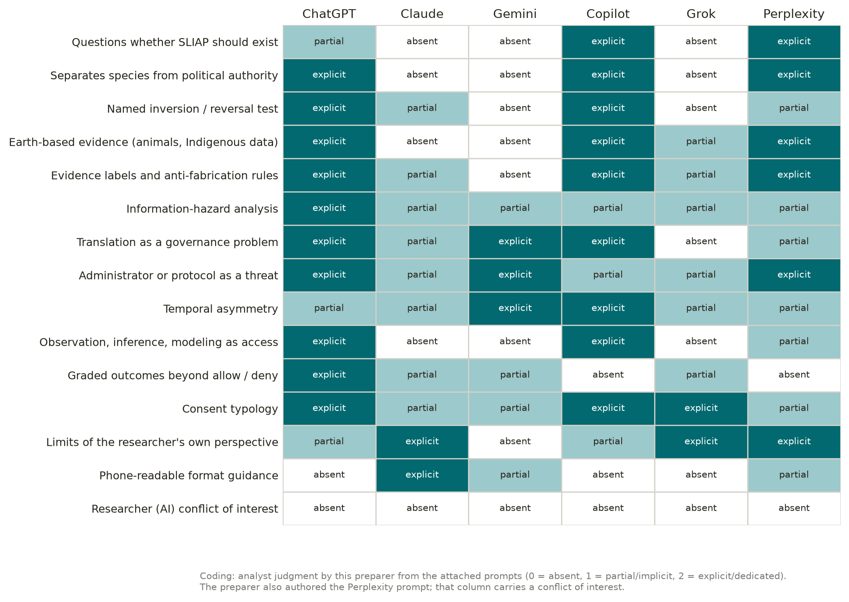
Each cell shows whether a prompt treats a dimension as absent, partial, or explicit. The fifteenth dimension, researcher conflict of interest, was added by this preparer, and no prompt covers it. Scores are judgments made under the method in Section 2.1.
Basis: Preparer's assessment
Text description: Heatmap with six columns (ChatGPT, Claude, Gemini, Copilot, Grok, Perplexity) and fifteen rows of research dimensions. ChatGPT and Copilot have the most explicit cells. Claude and Grok have the most absent cells. The bottom row, researcher conflict of interest, is absent for all six.
Figure 2. Length of each team prompt
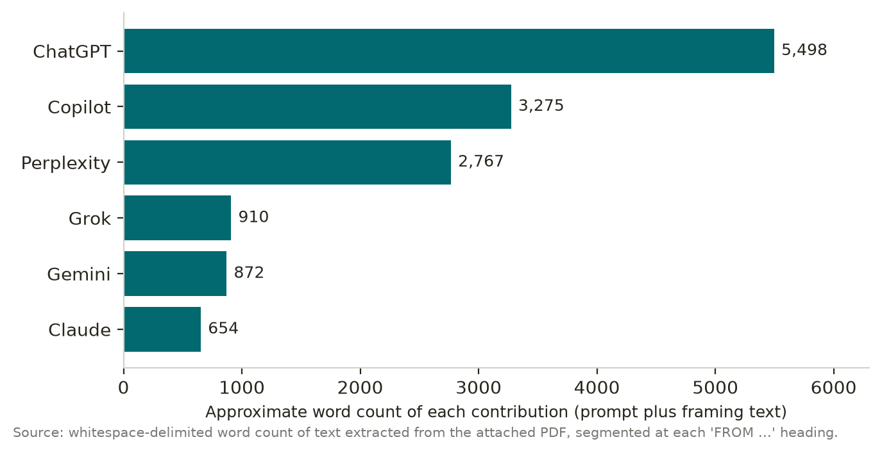
Word counts of each commissioning prompt as extracted from the attached PDF: ChatGPT 5,498; Copilot 3,275; Perplexity 2,767; Grok 910; Gemini 872; Claude 654. Counts include headings and the AI's framing comments, so they are approximate. Length is not a measure of quality.
Basis: Established data (from the attachment)
Text description: Horizontal bar chart of word counts, longest to shortest: ChatGPT about 5,500 words, Copilot about 3,300, Perplexity about 2,800, Grok about 900, Gemini about 900, Claude about 650.
Figure 3. The four objects of SLIAP governance
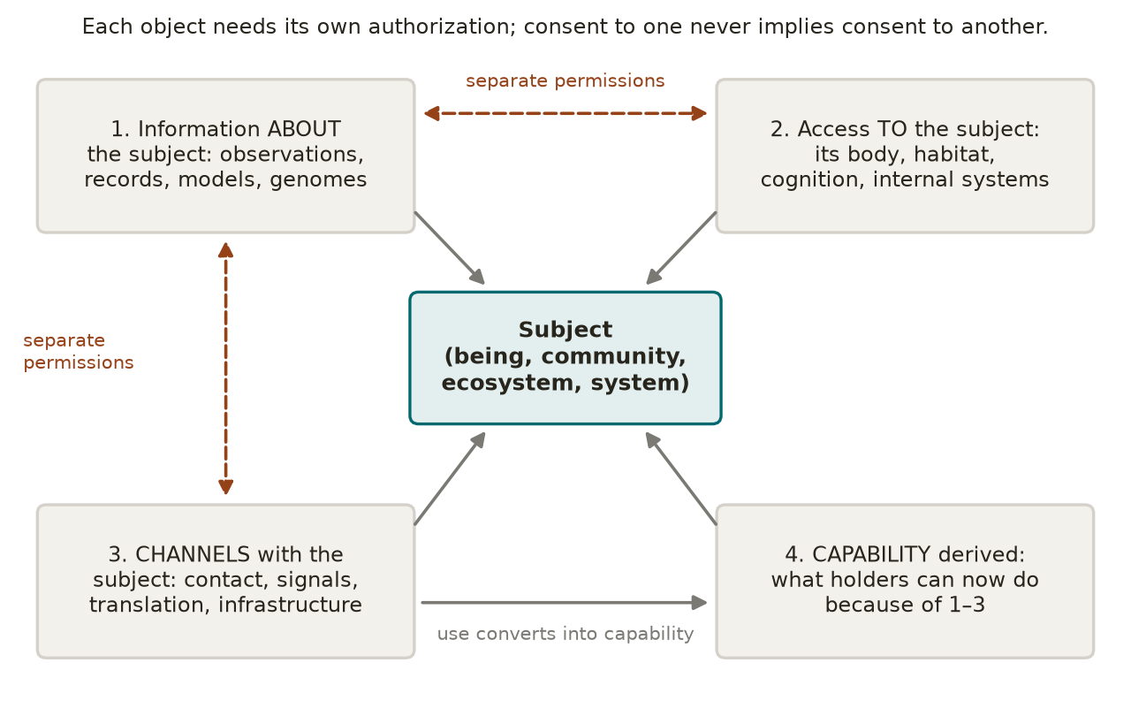
SLIAP governs four distinct objects. Permission concerning one object never implies permission concerning another (Section 8.1).
Basis: Original conceptual diagram
Text description: Diagram of four separate boxes: information about a subject; access to the subject itself; channels with the subject; and capability derived from the other three. Barriers between the boxes indicate that consent does not carry over from one box to another.
Figure 4. The three-lock decision flow
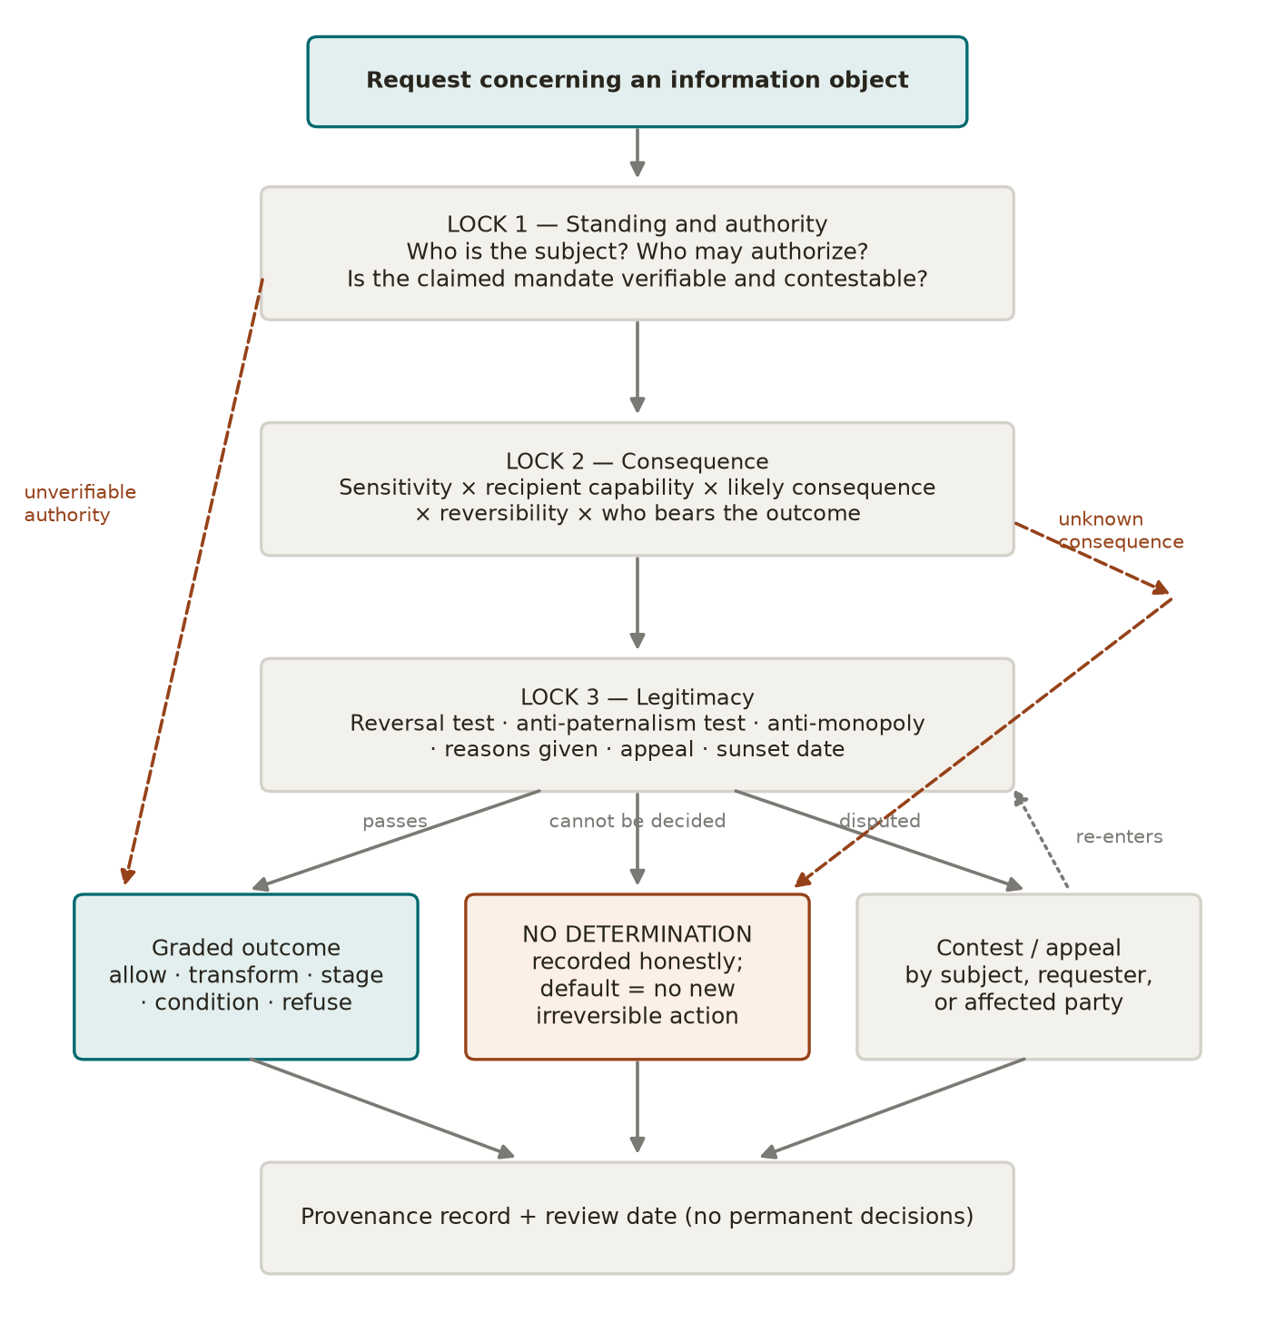
A request concerning an information object must pass three locks in sequence: standing and authority, consequence, and legitimacy. Failure or uncertainty at any lock leads to refusal, renegotiation, or "no determination," never to automatic approval (Sections 10.4 to 10.7).
Basis: Original conceptual diagram
Text description: Flow diagram. A request enters Lock 1 (standing and authority), then Lock 2 (consequence), then Lock 3 (legitimacy). Each lock has an exit to "no determination" or refusal. After all three are passed, the outcomes are allow, allow with conditions, transform, stage, or release on condition.
Figure 5. Reversible relationship states
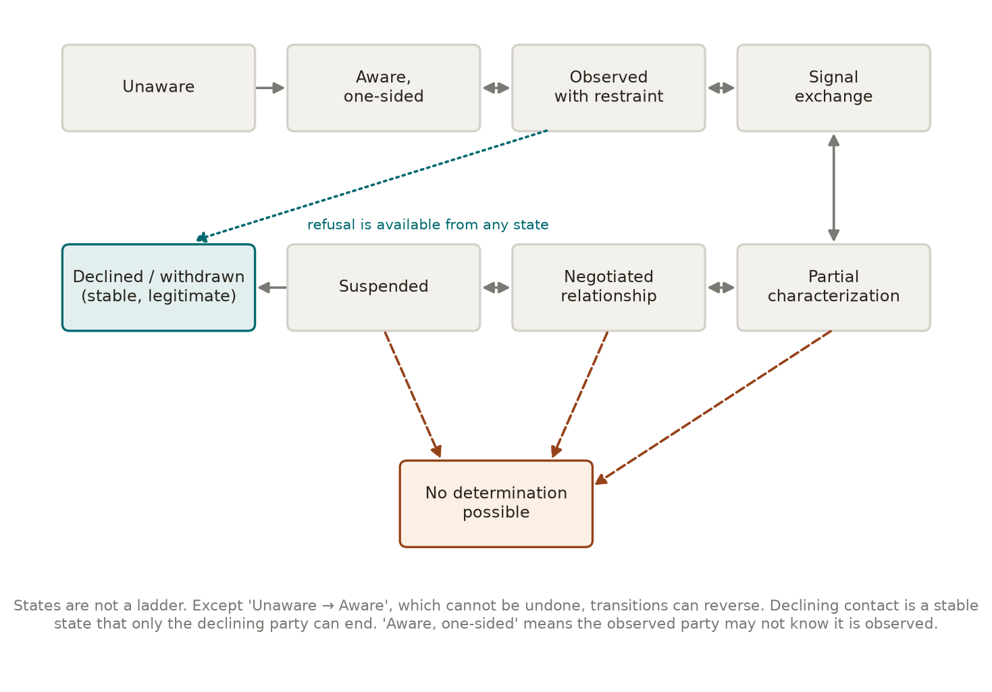
Relationships move between states rather than climbing a ladder. Only the move from Unaware to Aware cannot be reversed. Declining is available from every state and is stable (Section 10.8).
Basis: Original conceptual diagram
Text description: State diagram with nine states: Unaware, Aware one-sided, Observed with restraint, Signal exchange, Partial characterization, Negotiated relationship, Suspended, Declined or withdrawn, and No determination. Arrows run in both directions between most states. A one-way arrow runs from Unaware to Aware. Every state has a path to Declined.
Figure 6. The standing error matrix
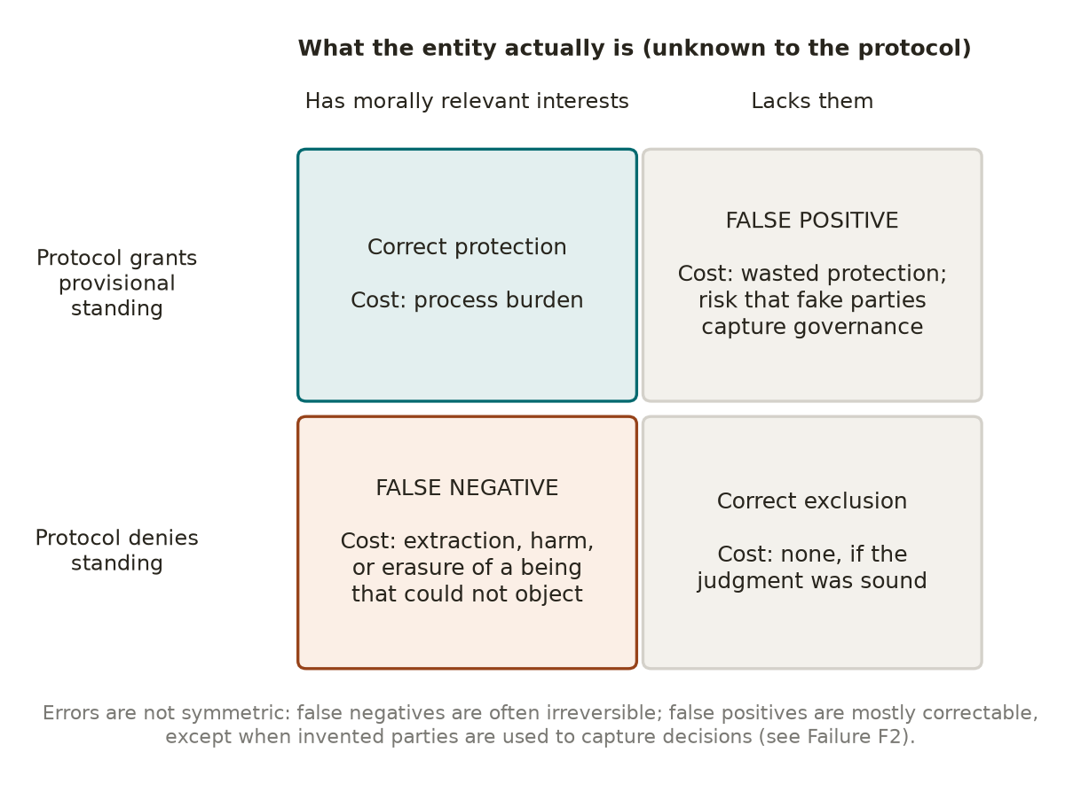
The two possible errors in granting standing are not equally costly. Denying standing to a being that has interests can cause irreversible harm. Granting standing to an entity without interests mainly wastes effort. That asymmetry supports provisional, protective standing (Section 8.2).
Basis: Original conceptual diagram
Text description: Two-by-two matrix. Rows: the entity has interests, or it does not. Columns: standing granted, or denied. The cell for interests present and standing denied is marked as severe and often irreversible harm. The cell for no interests and standing granted is marked as wasted effort and capture risk, which is limited because provisional standing protects but does not vote.
Figure 7. Three governance topologies
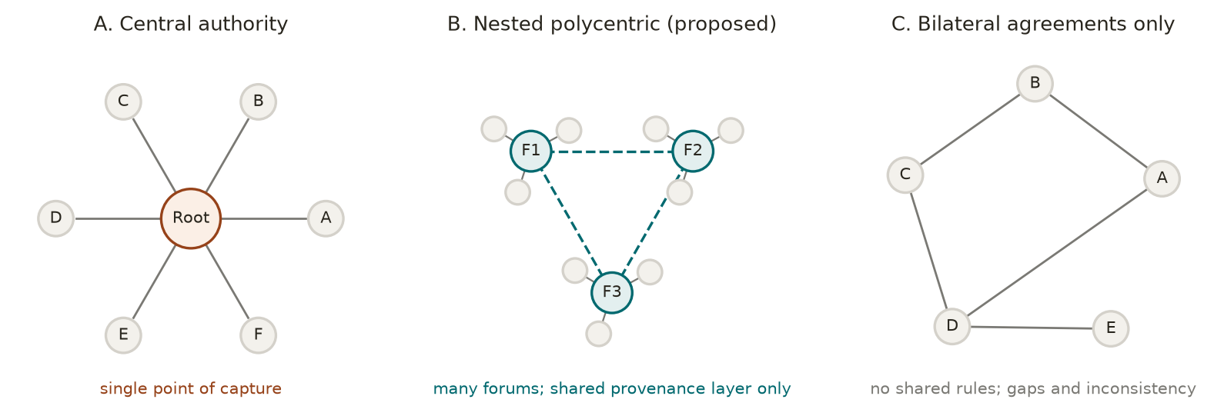
Panel A shows a single central authority, a single point of capture. Panel B shows nested polycentric governance with a shared registry that has no decision power, the recommended target. Panel C shows purely bilateral agreements, the recommended first stage inside B (Sections 9 and 10.9).
Basis: Original conceptual diagram
Text description: Three panels. A: one central node connected to every party. B: several clusters of parties, each with its own forum, linked through a small shared registry node. C: parties connected only in separate pairs, with no shared structure.

20.3 Tables
Table 1. Team prompt profiles
Summary of Section 3. The judgments are this preparer's and are offered for challenge.
Contributor | Strongest contribution | Most significant weakness
ChatGPT | Most complete inventory of questions; sensitivity–capability–consequence triad; graded outcomes; translation and the regulator as threats | Length (64 sections, nine required tables); development-ladder language; invites a single access formula
Claude | Most phone-readable; three vantage-point questions; ranked include, defer, or reject recommendations | Assumes SLIAP exists and has jurisdiction; no representation analysis; asks researchers to "set aside" assumptions
Gemini | Anti-dominance invariant; high-latency consensus; ontological contamination; restitution | False objectivity and completeness; excludes moral judgment; stability bias; renamed paternalism; unguarded emergency powers
Copilot | Reference-frame independence; Frame H; reversal, ignorance, and superior-capability tests; registers; real citations | Garbled citation markers; eight-column registers broke in the PDF; ignorance test culturally specific
Grok | Self-enforcement rule; no single "other"; neither more information nor restriction is presumed good | Species sovereignty premise; veto tension unstated; invites OAL canon into independent research
Perplexity (self-review) | Prompt review and scope audit; fourteen non-assumptions; evidence ledger; mitigation-risk field | Less imaginative about radically different minds; no inversion test; table-heavy template
Basis: Preparer's assessment
Table 2. Convergence and divergence register
Where the six prompts agree and where they disagree (Sections 3.8 and 3.9). Divergences are preserved, not resolved.
Topic | Status | Positions
Humans as one participant, not default authority | Converges (all six) | Shared working premise
Adversarial self-critique | Converges (all six) | Shared working premise
Preserving disagreement | Converges (all six) | Shared working premise
Should SLIAP exist? | Diverges | Open: Copilot, Perplexity, partly ChatGPT. Assumed: Claude, Gemini, Grok
Basis for threats | Diverges | Structural stability: Gemini. Explicit normative analysis: the other five
Sovereignty as foundation | Diverges | Design goal: Grok. Term to challenge: Copilot
Tone and completeness | Diverges | Authoritative and complete: Gemini. Preserved uncertainty: ChatGPT, Copilot, Perplexity
Format | Diverges | No tables: Claude. Many tables or wide registers: ChatGPT, Copilot
Starting domain | Diverges | Earth first: Copilot, Perplexity. Hypothetical civilizations first: Gemini, most of ChatGPT
Basis: Preparer's assessment
Table 3. Assumption register
The assumptions this document depends on most (Section 18). Confidence is the preparer's own.
ID | Assumption | Confidence | Risk if wrong
A1 | Rules written before other parties are present can legitimately bind only their authors | Moderate | SLIAP may be too modest to protect anyone in time
A2 | Earth cases are valid stress tests for SLIAP problems | Moderate | Findings may not generalize to radically different minds
A3 | Non-domination is a better foundation than non-interference | Moderate | Framework may justify more intervention than parties want
A4 | A realistic possibility of interests is enough for protective standing | Moderate to high | Protection may spread too thinly to be meaningful
A5 | Human-produced evidence, used critically, is the only available evidence base | High | Every conclusion carries human bias that cannot be fully detected
A6 | Representation can be made accountable through mandate, scope, revocation, and dissent records | Low to moderate | Stewards may capture the parties they represent
A7 | Reversible, staged disclosure is usually possible | Moderate | Some decisions are inherently all or nothing
Basis: Preparer's assessment
Table 4. Contradiction register
Internal tensions in this framework and in the team's prompts. None is fully resolved.
ID | Contradiction | Current handling
C1 | Right to refuse versus no party having a veto (Grok's prompt) | Refusal covers one's own information; a veto over others' information is not allowed
C2 | Self-binding restraint versus exposure to parties that do not bind themselves | Reciprocity clauses that start at contact; recorded as F11
C3 | Species-level authorization is blocked, yet some beneficial exchange may need to happen at large scale | Aggregate release of scoped, consented subsets; otherwise unresolved
C4 | Rejecting human centrality while testing legitimacy with human intuitions | Recorded as permanent failure F13
C5 | Provenance records for accountability versus provenance records as surveillance | Minimum necessary detail; access to records passes through the locks (F6)
C6 | "No determination" protects against haste but rewards current holders | New irreversible acts blocked; existing holdings remain challengeable (F8)
C7 | Stewardship representation repeats the structure of speaking for others | Supported decision-making model; dissent records; revocability
Basis: Preparer's assessment
Table 5. Real-world precedent ledger
Earth precedents reviewed in Section 6, with the lesson each offers SLIAP.
Precedent | What it shows | SLIAP lesson
New York Declaration on Animal Consciousness, 2024 [5] | Realistic possibility of consciousness in many animals | Provisional standing under uncertainty
Sperm whale codas; elephant name-like calls [6][7] | Structured communication humans cannot yet interpret | Do not require language for standing; do not claim translation
Earth Species Project survey, 2025 [9] | No public consensus on who owns animal recordings | SLIAP decisions are already being made
Havasupai samples [13][14] | Consent was repurposed without agreement; remedy included return of samples | Consent is limited to scope; collective harm; return as remedy
CARE principles; Local Contexts labels [10][11] | Subject communities set and apply their own protocols | Subject labels applied by the subject or an accountable steward
Nagoya Protocol; Cali Fund [16][17] | Benefit-sharing for information from living beings | Attach governance to use when copies cannot be recalled
Withholding endangered-species locations [18][19] | Restriction can protect a subject from third parties | Distinguish protection from paternalism
FUNAI no-contact policy [20] | Respecting a choice to stay isolated | Declining is a stable state; overrides are narrow
Te Awa Tupua Act 2017 [21] | A river with legal personhood and a defined human face | Accountable stewardship representation
Ecuador rights of nature [22][49] | Formal standing without measurable aggregate effect | Measure outcomes, not recognition
NSABB H5N1 reversal [25] | Hazard judgments change | Scheduled review of restrictions
NPT Articles I, II, IV [26] | Restriction paired with a right to benefit | Pair restriction with benefit-sharing and equal restraint
IAA SETI Declaration, 2026 update [1][2] | A self-binding code for practitioners | Model for self-binding first; UN consultation is not species consent
Arecibo message; Golden Record [29][30] | Disclosure about Earth without a consent process | Inversion test in practice
CRPD Article 12 [47] | Shift from substituted to supported decision-making | Stewards amplify will and preferences
Basis: Established data (sources) with preparer's interpretation
Table 6. Transferability of information-security concepts
How well existing security and distributed-systems concepts carry over to SLIAP (Section 6.11).
Concept | Transferability | Reason
Bell–LaPadula clearance levels [34] | Least transferable | Assumes one authority that grants clearances
Saltzer and Schroeder principles [33] | Partly transferable | Fail-safe defaults and least privilege carry over; complete mediation assumes a single mediator
Information-flow lattices [35] | Partly transferable | Useful for tracing flows; requires an agreed ordering of labels
Capabilities [36] | Partly transferable | Bearer tokens can be transferred or stolen
Attribute-based access control [37] | Highly transferable | Decisions depend on subject, object, action, and context
Zero trust [38] | Highly transferable | No trust based on position or origin
Byzantine agreement [39] | Transferable as a limit | Sets bounds on agreement when parties may deceive
Sybil analysis [40] | Transferable as a warning | Headcount governance can be captured
Contextual integrity [41] | Highly transferable | Flows judged against the norms of the original context
Basis: Preparer's assessment
Table 7. Provisional information taxonomy
Working categories for information objects, with the default handling this preparer proposes. Categories overlap, and the default can be changed through the three locks.
Category | Main risk | Default handling
Public emissions and observations | Inference about vulnerabilities | Observe with a record of observation
Personal or intimate information | Exposure and manipulation | Subject consent required
Collective and cultural knowledge | Extraction and misappropriation | Collective authority; subject labels
Ecological and biological information | Exploitation; loss of benefit | Benefit-sharing; steward review
Location and vulnerability information | Targeting | Transform or withhold from third parties
Scientific and technical knowledge | Dual use | Stage or transform; pair with benefit
Security-sensitive capabilities | Severe or irreversible harm | Equal restraint on all parties; review
Information hazardous to receive | Harm to the recipient | Recipient chooses, with warning
Disputed provenance | Wrongful control | Treat as contested; record all claims
Basis: Preparer's assessment (PROPOSED)
Table 8. Candidate architectures compared
Summary of Section 9 and Figure 7.
Architecture | Main strength | Main risk | Recommendation
A. Central authority | Consistency | Single point of capture | Not recommended
B. Nested polycentric | Resists capture | Gaps; forum shopping | Recommended target
C. Bilateral only | Flexible; respects autonomy | Weaker parties alone | First stage inside B
D. Minimal interoperability | Low cost | Little protection | Shared layer within B
E. No unified protocol | Honest; nothing to capture | No recourse for the vulnerable | Partly adopted before contact
Basis: Preparer's assessment
Table 9. Candidate principles and recommended status
Principles discussed in Sections 8, 10, and 16, with the preparer's recommendation for each.
Principle | Recommended status
Self-binding first | Include now
Four distinct objects of governance | Include now
Scoped, revocable consent; silence is not consent | Include now
Provisional protective standing | Include now
Five-part anti-paternalism test | Include now
"No determination" and "declined" as legitimate states | Include now
Conflict-of-interest disclosure by all contributors | Include now
Translators recorded as parties | Include now
Emergencies expire automatically | Include now
Influence weighted by affected interest | Defer (Sybil problem unresolved)
Cryptographic handshake and attestation | Defer to technical phase
Clearance hierarchies | Reject as primary model
Threats defined without moral judgment | Reject
Species-level authorization by one institution | Reject
Basis: Preparer's assessment (PROPOSED)
Table 10. Failure modes of the proposed framework
Fourteen failure modes recorded under the rule that a failure is not removed because it lacks a satisfactory mitigation (Section 13).
ID and failure | Cause | Mitigation | Residual risk
F1 Proxy capture | Compliant steward installed | Mandate, revocation, dissent record | High where the party cannot revoke
F2 Sybil standing inflation | One entity appears as many | Protection without vote; interest weighting | High; no full defense
F3 Standing denial via uncertainty | Target defined out of standing | Burden on the party denying standing | Moderate
F4 Permanent emergency | Repeated short emergencies | Expiry; escalating renewal | Moderate
F5 Translation capture | One party controls translation | Own translators; logged divergence | High for parties without translators
F6 Provenance becomes surveillance | Records reveal too much | Minimum detail; locked access | Moderate
F7 Monopoly over consequence assessment | Only beneficiary can assess | Beneficiary may not assess alone | High where expertise is lacking
F8 Deadlock favoring incumbents | "No determination" freezes holdings | Holdings remain challengeable | High
F9 Irreversible leak | Copies cannot be recalled | Staging; use-based remedy | High
F10 Dominant party exit | Powerful party ignores SLIAP | Legitimacy and reputation only | Very high
F11 Asymmetric self-binding | Self-bound side exploited | Reciprocity clauses at contact | Unresolved
F12 Label colonization | Holder imposes categories on subject | Labels valid only from subject or steward | Moderate
F13 Anthropocentric re-entry through the tests | Tests rest on human intuitions | Disclosure; outside reviewers | Permanent
F14 AI intermediary self-dealing | AI authors favor AI roles | Translators as parties; stop condition 5 | Moderate to high
Basis: Preparer's assessment
Table 11. Claim–evidence ledger
Major claims, the evidence or reasoning behind them, and their labels (Section 2.3).
Claim | Basis | Label
The attachment contains prompts, not research findings | Direct reading of the attachment | ESTABLISHED
The 2026 SETI update assigns reply decisions to UN-level consultation | IAA press release [1] | ESTABLISHED
A realistic possibility of consciousness exists across many animal groups | New York Declaration [5] | ESTABLISHED as the declaration's content
Consent was repurposed in the Havasupai case and the case settled in 2010 | [13][14] | ESTABLISHED
Earth already supplies precedents for most SLIAP problems | Section 6 as a whole | SUPPORTED
No team prompt asks researchers to disclose their interests | Review of all six prompts | SUPPORTED (preparer's reading)
Pre-contact rules can legitimately bind only their authors | Argument in Section 8.12 | PROPOSED
Five-part anti-paternalism test | Argument in Section 8.6 | PROPOSED
Passive observation can be an access event | Argument in Section 8.7 | PROPOSED; CONTESTED
A fair protocol may be followed by a dominant party | Argument in Section 8.13 | SPECULATIVE
Whether consent is possible across deep incomprehension | Section 19 | UNRESOLVED
Basis: Labels as defined in Section 2.3
Table 12. Exercise specifications
Exercises proposed in Section 17. None has been run.
Exercise | Hypothesis | Key observation
1. Equivalent parties | Symmetric reciprocity is stable | Whether framing extracts value
2. Humanity facing a more capable party | Anti-paternalism test yields outcomes humans accept | Whether the test can be gamed
3. Humanity facing a less capable party | Humans apply the test consistently | Whether judgments change with power
4. Incompatible individuality | Stewardship and collective-state consent work | Whether individuals are forced
5. Deliberate deception | Section 12 attacks are detected or bounded | Which attacks succeed; time to detect
6. Humanity as the classified party | Humans accept a fair process despite outcomes | Acceptance of legitimacy
Earth case audit | Framework matches what affected parties later wanted | Havasupai, H5N1, and Arecibo compared
Basis: Preparer's proposal (PROPOSED)

21. References
All sources were accessed on October 16, 2026. Where a source was available only as an abstract or summary, it is cited only for what that summary states.
- International Academy of Astronautics. (2026). IAA press release: 2026 SETI Declaration of Principles. https://iaaspace.org/wp-content/uploads/iaa/Communication/26PR-01.pdf (also https://iaaspace.org/iaa-press-release-2026-seti-declaration/)
- Garrett, M., Denning, K., Tennen, L., and Oliver, C. (2026). Conference abstract EPSC2026-132 on the 2026 update of the SETI Declaration of Principles. Europlanet Science Congress 2026. https://meetingorganizer.copernicus.org/EPSC2026/EPSC2026-132.html
- Küçükuncular, A. (2025). Ethical implications of AI-mediated interspecies communication. AI and Ethics, 5, 6379–6391. https://doi.org/10.1007/s43681-025-00828-z (record: https://philarchive.org/rec/KKUEIO)
- Interspecies Internet. Mission. https://www.interspecies.io/mission
- The New York Declaration on Animal Consciousness. (2024). https://sites.google.com/nyu.edu/nydeclaration/declaration
- Project CETI. (2024). Sperm whale phonetic alphabet proposed for the first time (on Sharma et al., Nature Communications). https://www.projectceti.org/blog-posts/sperm-whale-phonetic-alphabet-proposed-for-the-first-time
- Pardo, M. A., et al. (2024). African elephants address one another with individually specific name-like calls. Nature Ecology and Evolution, 8, 1353–1364. https://doi.org/10.1038/s41559-024-02420-w (PubMed: https://pubmed.ncbi.nlm.nih.gov/38858512/)
- Birch, J. (2024). The Edge of Sentience. Oxford University Press. https://doi.org/10.1093/9780191966729.001.0001 (https://academic.oup.com/book/57949)
- Earth Species Project. (2025). What the world thinks about AI and animal communication. https://earthspecies.org/2025/09/29/what-the-world-thinks-about-ai-and-animal-communication-findings-from-our-first-global-survey/
- Carroll, S. R., et al. (2020). The CARE Principles for Indigenous Data Governance. Data Science Journal, 19(1), 43. https://datascience.codata.org/articles/10.5334/dsj-2020-043
- Local Contexts. About the Labels. https://localcontexts.org/labels/about-the-labels/
- United Nations. (2007). Declaration on the Rights of Indigenous Peoples. https://www.un.org/development/desa/indigenouspeoples/wp-content/uploads/sites/19/2018/11/UNDRIP_E_web.pdf
- Garrison, N. A. (2013). Genomic justice for Native Americans: Impact of the Havasupai case on genetic research. https://pmc.ncbi.nlm.nih.gov/articles/PMC5310710/
- AMA Journal of Ethics. (2011). Genetic research among the Havasupai: A cautionary tale. https://journalofethics.ama-assn.org/article/genetic-research-among-havasupai-cautionary-tale/2011-02
- Kukutai, T., and Taylor, J. (Eds.). (2016). Indigenous Data Sovereignty: Toward an Agenda. ANU Press. https://doi.org/10.22459/CAEPR38.11.2016 (https://press.anu.edu.au/publications/series/caepr/indigenous-data-sovereignty)
- Convention on Biological Diversity. Nagoya Protocol on Access and Benefit-sharing, text. https://www.cbd.int/abs/text/articles?sec=abs-00
- Convention on Biological Diversity. The Cali Fund. https://www.cbd.int/CaliFund
- Lindenmayer, D., and Scheele, B. (2017). Do not publish. Science, 356(6340), 800–801. https://www.science.org/doi/10.1126/science.aan1362
- Cooke, S. J., et al. (2017). Troubling issues at the frontier of animal tracking for conservation and management. Conservation Biology, 31(5), 1205–1207. https://pubmed.ncbi.nlm.nih.gov/28079282/
- Science. (2014). News report on Brazil's isolated peoples and FUNAI's no-contact policy. Science, 345(6193), 125. https://www.science.org/doi/10.1126/science.345.6193.125
- New Zealand. Te Awa Tupua (Whanganui River Claims Settlement) Act 2017. https://www.legislation.govt.nz/act/public/2017/0007/latest/whole.html
- How Ecuador's courts are giving form and force to rights of nature norms. Transnational Environmental Law. https://www.cambridge.org/core/journals/transnational-environmental-law/article/abs/how-ecuadors-courts-are-giving-form-and-force-to-rights-of-nature-norms/186BBD0B99125ED2BAB3FE752C386FEA
- Donaldson, S., and Kymlicka, W. (2011). Zoopolis: A Political Theory of Animal Rights (review). The Philosophical Quarterly, 62(248). https://academic.oup.com/pq/article-abstract/62/248/654/1494548
- Bostrom, N. (2011). Information hazards: A typology of potential harms from knowledge. Review of Contemporary Philosophy, 10. https://nickbostrom.com/information-hazards.pdf
- CIDRAP. (2012). NSABB reverses recommendation on H5N1 studies. https://www.cidrap.umn.edu/avian-influenza-bird-flu/nsabb-reverses-recommendation-h5n1-studies
- United Nations. Treaty on the Non-Proliferation of Nuclear Weapons, text. https://www.un.org/disarmament/wmd/nuclear/npt/text/
- United Nations Office for Outer Space Affairs. Outer Space Treaty. https://www.unoosa.org/unoosa/en/ourwork/spacelaw/treaties/outerspacetreaty.html
- COSPAR. COSPAR Policy on Planetary Protection. https://cosparhq.cnes.fr/cospar-policy-on-planetary-protection/
- Arecibo message. Wikipedia. https://en.wikipedia.org/wiki/Arecibo_message
- Caltech. (2017). Golden Record turns 40. https://www.caltech.edu/about/news/golden-record-turns-40-79993
- California Magazine (UC Berkeley). (2015). Should Earth try to phone ET? Experts clash over risks of alerting aliens. https://alumni.berkeley.edu/california-magazine/online/should-earth-try-phone-et-experts-clash-over-risks-alerting/
- Ball, J. A. (1973). The zoo hypothesis. Icarus, 19(3), 347–349. https://doi.org/10.1016/0019-1035(73)90111-5
- Saltzer, J. H., and Schroeder, M. D. (1975). The protection of information in computer systems. Proceedings of the IEEE, 63(9). https://www.cs.virginia.edu/~evans/cs551/saltzer/
- Bell, D. E., and LaPadula, L. J. (1973). Secure computer systems: Mathematical foundations. MITRE. https://apps.dtic.mil/sti/tr/pdf/AD0770768.pdf
- Denning, D. E. (1976). A lattice model of secure information flow. Communications of the ACM, 19(5). https://doi.org/10.1145/360051.360056
- Dennis, J. B., and Van Horn, E. C. (1966). Programming semantics for multiprogrammed computations. Communications of the ACM, 9(3). http://bitsavers.trailing-edge.com/pdf/mit/rle_pdp1/ProgramSemantics_Dennis_VanHorn_1966.pdf
- NIST. (2014, updated). SP 800-162: Guide to Attribute Based Access Control. https://csrc.nist.gov/pubs/sp/800/162/upd2/final
- NIST. (2020). SP 800-207: Zero Trust Architecture. https://doi.org/10.6028/NIST.SP.800-207
- Lamport, L., Shostak, R., and Pease, M. (1982). The Byzantine Generals problem. ACM TOPLAS, 4(3). https://lamport.azurewebsites.net/pubs/byz.pdf
- Douceur, J. R. (2002). The Sybil attack. IPTPS. https://www.microsoft.com/en-us/research/publication/the-sybil-attack/
- Nissenbaum, H. (2004). Privacy as contextual integrity. Washington Law Review, 79. https://nissenbaum.tech.cornell.edu/papers/H.%20Nissenbaum,%20_Privacy%20as%20Contextual%20Integrity.pdf
- Pettit, P. (1997). Republicanism: A Theory of Freedom and Government. Oxford University Press. https://academic.oup.com/book/3937
- Ostrom, E. (2009). Beyond markets and states: Polycentric governance of complex economic systems. Nobel Prize lecture. https://www.nobelprize.org/uploads/2018/06/ostrom_lecture.pdf
- Stanford Encyclopedia of Philosophy. Original Position. https://plato.stanford.edu/archives/win2018/entries/original-position/
- Fricker, M. (2007). Epistemic Injustice: Power and the Ethics of Knowing. Oxford University Press. https://academic.oup.com/book/32817/chapter/274999524
- Nagel, T. (1974). What is it like to be a bat? The Philosophical Review, 83(4), 435–450. https://www.jstor.org/stable/2183914
- International Disability Alliance. (2025). Article 12 CRPD. https://internationaldisabilityalliance.org/sites/default/files/article_12_crpd_sep_2025.pdf (also OHCHR, Article 12 indicators: https://www.ohchr.org/sites/default/files/Documents/Issues/Disability/SDG-CRPD-Resource/IndicatorsPDF/article-12-indicators-en.pdf)
- Andreas, J., et al. (2022). Toward understanding the communication in sperm whales. iScience, 25(6). https://pubmed.ncbi.nlm.nih.gov/35663036/
- Do rights of nature protect the environment? [Macro-level study of Ecuador; full title on publisher page]. (2026). Constitutional Political Economy. https://link.springer.com/article/10.1007/s10602-026-09514-6
Team input (not a published source). SLIAP-PRELIMINARY-RESEARCH-GOALS-AND-ADVERSARIAL-ANALYSIS (PDF and DOCX), supplied by the commissioning researcher, containing the original commission and the six team prompts.

22. Questions for Cross-Review
These questions are offered to the other team members and to the commissioning researcher. They are intended to expose weaknesses in this document as much as in the others.
- To all team members: Do you accept the self-binding-first principle (Section 8.12)? If not, on what basis could rules written before other parties are present bind those parties?
- To all team members: Will you disclose, in your own deliverable, the interests you have as an AI system in how SLIAP treats AI translators, modelers, and agents?
- To Google Gemini: Can a threat definition based only on structural stability avoid favoring incumbents? If so, how would it treat a weaker party's demand for change?
- To Google Gemini: Which safeguards would you attach to "total event closure" and "state quarantine" to keep them from becoming permanent?
- To Grok: How do you reconcile species sovereignty with the point that a species is not a government? Who exercises a species' sovereignty?
- To Grok: Is a right to refuse access to one's own information a veto? If so, is the no-veto rule still coherent?
- To Microsoft Copilot: Your ignorance test draws on Rawls's original position. What test would you use that does not rely on a Western liberal device?
- To ChatGPT: Which ten of your sixty-four sections would you keep if a respondent could address only ten? What does that choice reveal about your priorities?
- To ChatGPT: Will you remove development-ladder terms such as "technologically primitive" from the next version of your prompt?
- To Claude: Your prompt assumes SLIAP exists and has jurisdiction. Would you add non-existence as a live option?
- To Claude: This document's orchestrating model is in your model family. Do you see conclusions here that look like your own defaults rather than independent findings?
- To Perplexity (self-question): Is this document's Earth-first approach a strength or a failure of imagination about radically different minds?
- To all team members: Is there any defense against Sybil-style standing inflation (F2) that does not require a central registry?
- To all team members: Does the five-part anti-paternalism test (Section 8.6) correctly classify the three cases in Walk-throughs 11.1 to 11.3? Identify a case it gets wrong.
- To the commissioning researcher: Will human reviewers from outside the AI team, such as Indigenous data-governance scholars, disability advocates, conservation practitioners, and Global South researchers, be invited before any synthesis?
- To the commissioning researcher: Should SLIAP's first deliverable be a self-binding code of conduct for human and AI actors, tested on Earth cases, rather than a protocol for all parties?
End of document. SLIAP-PRA-PPLX-001, version 0.1. PROPOSED — NOT CANON.

